The Prime Machine HD Guide
I want to … use corpus examples for assignment or worksheets
If you are studying English or linguistics as an undergraduate or postgraduate student, you may want to use corpus data as evidence or examples in your assignments. If you are teaching English, you may want to use corpus data to create handouts or worksheets. This guide will explain how to take concordance lines, concordance cards and other kinds of corpus data from The Prime Machine HD corpus tool to use in documents or presentations.

Steps to complete:
- Learn how to adjust the display settings to make clear images of concordance lines that will look good in documents and presentations.
- Learn how to filter concordance lines to show only the lines you want.
- Learn how to save images of concordance cards one at a time or in batches.
- Learn how to copy text from concordance lines or concordance cards to be presented as indented examples or block quotes.
- Learn how to make guess the missing word exercises using tPM’s mask settings to hide the node word and/or nearby words.
- Learn how to adjust columns of other data before creating images, sheets or PDFs.

This guide can help you:
- Avoid having images of concordance lines which are distorted or have text which is too small to read.
- Present single examples in different ways (cards, extracts, or block quotes).
- Create data driven learning activities for your students.
- Take advantage of table formatting options inside tPM.

What you’ll need to get started:
- The Prime Machine HD for Windows, MacOS, iPad, iPhone or Android (available free from https://www.theprimemachine.net/ )
- One or more words of interest to look up so you have corpus data to copy.
- Patience, enthusiasm and an open mind!

Getting started
The best place to get The Prime Machine HD (tPM) is from an official store. It is free!

Windows and Android users can also download the App directly from the website: https://www.theprimemachine.net
When you first use tPM, you almost certainly will want to connect to the server to access pre-prepared corpora and resources. There are three modes: Simple Mode, Full Mode and Game Mode. The Full Mode includes additional tabs and features for corpus research and DIY corpus work.
The main ‘hamburger’ or 蒸笼menu in the top-right corner allows you to connect and change mode.

Step 1: Learn how to adjust display settings for clear concordance lines

The Lines display on tPM has been designed to provide as much co-text to the left and right of the node as will fit on the screen. While the text may be clear and easy to read when looking at the lines inside the app, when you use images in documents or presentations, it is worth considering the best screen shape and size to ensure the text remains clear and the letters do not get distorted.

On Windows and macOS, you can resize the app window to try to match the shape you need for your document or presentation. On iPAd, iPhone and Android, you can use two finger zooming to increase the text size if necessary.

When you double-click, right-click or do a long tap on tPM’s display panels, a menu will appear which allows you to copy, save or share the data in different formats.

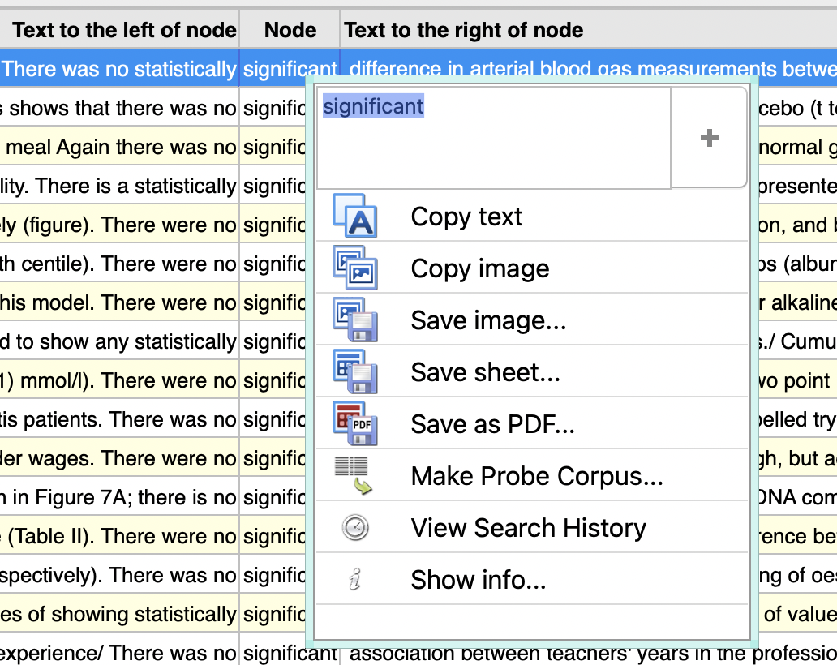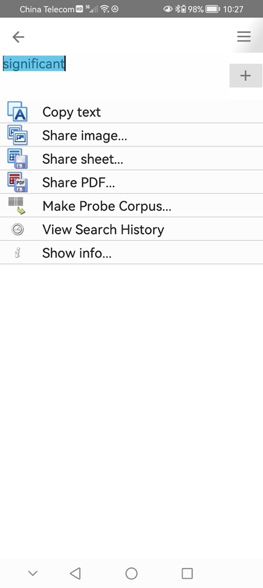

On Windows and macOS, concordance lines can be copied or saved as an image; saved as a spreadsheet; or saved as PDF. On iPad, iPhone and Android, images, sheets and PDFs can be shared (and you may be able to use your device’s share menu to save).

If you take a screenshot, the currently selected line will be blue, and the user interface will be visible.

If you use the built-in functions to copy, save or share, it will not show the selected line.
An image created when the app is fully maximized is not going to be ideal for use in a document, especially since we tend to use documents in portrait layout, while a screen is usually in landscape. The text in the image below is rather too small.

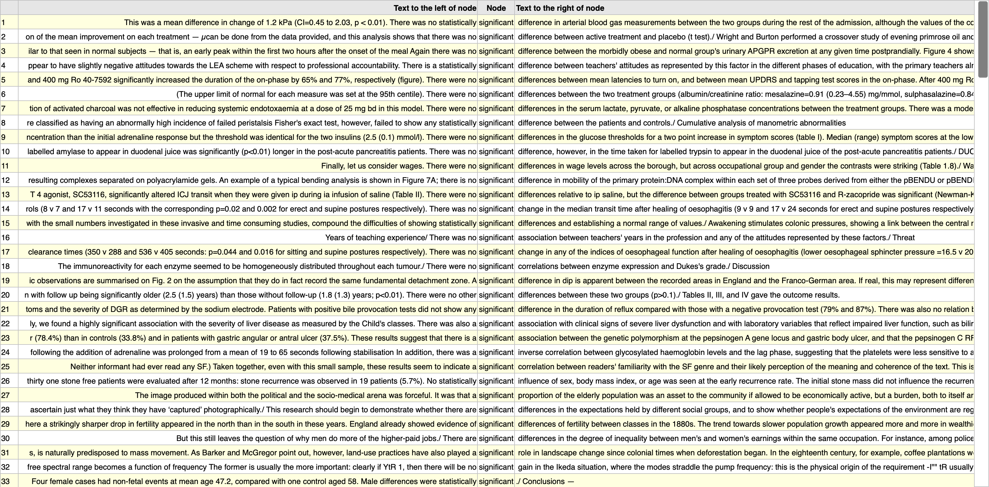

The text size can be zoomed on Windows (CTRL + mouse scroll or two finger scroll) and macOS (control + mouse scroll or two finger scroll).

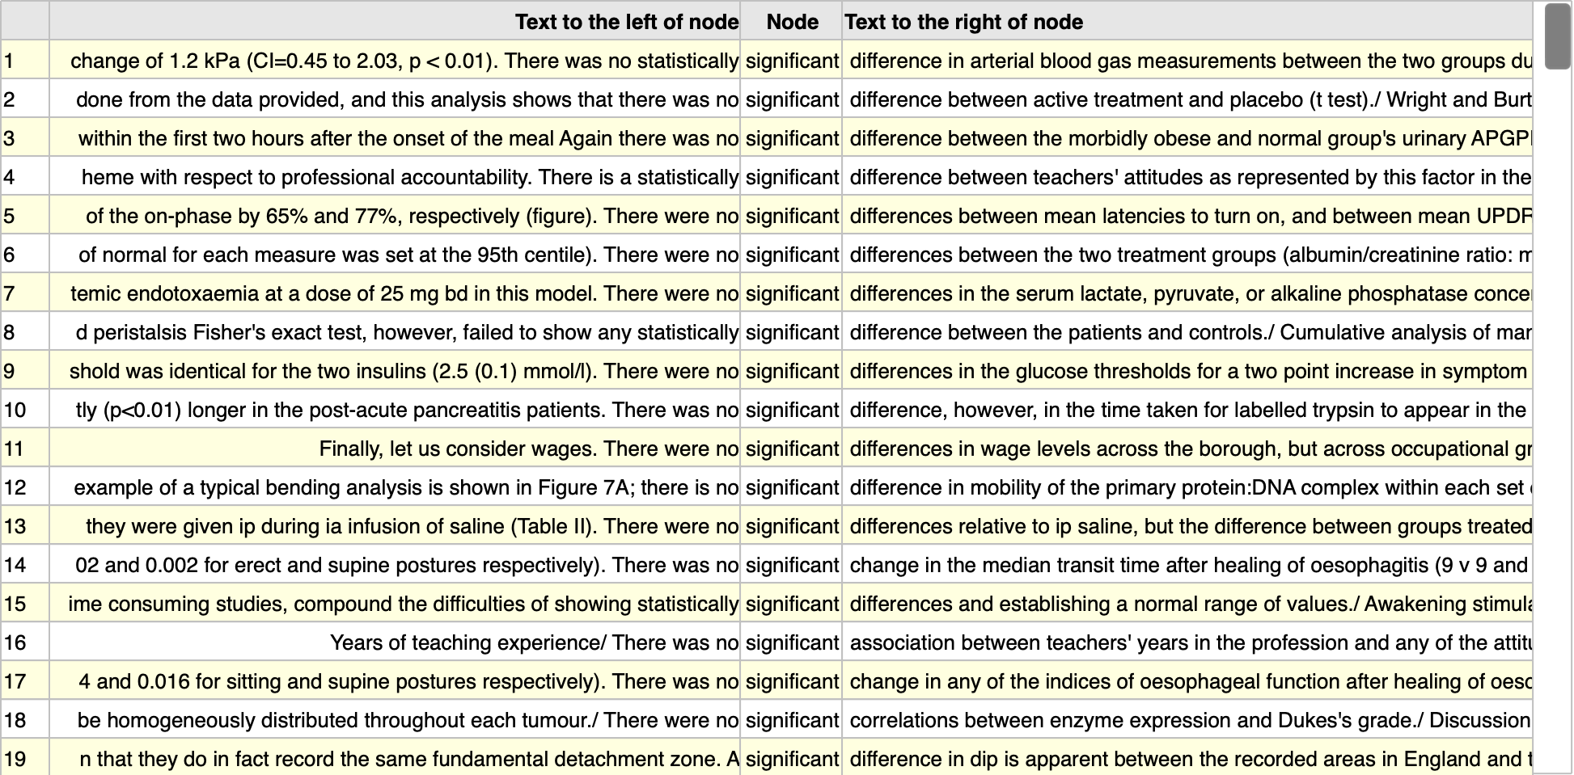

Pressing CTRL + 1 or control + 1 will reset the displays.

Alternatively, you can resize the window to make it occupy less of the desktop. You can also make it taller.
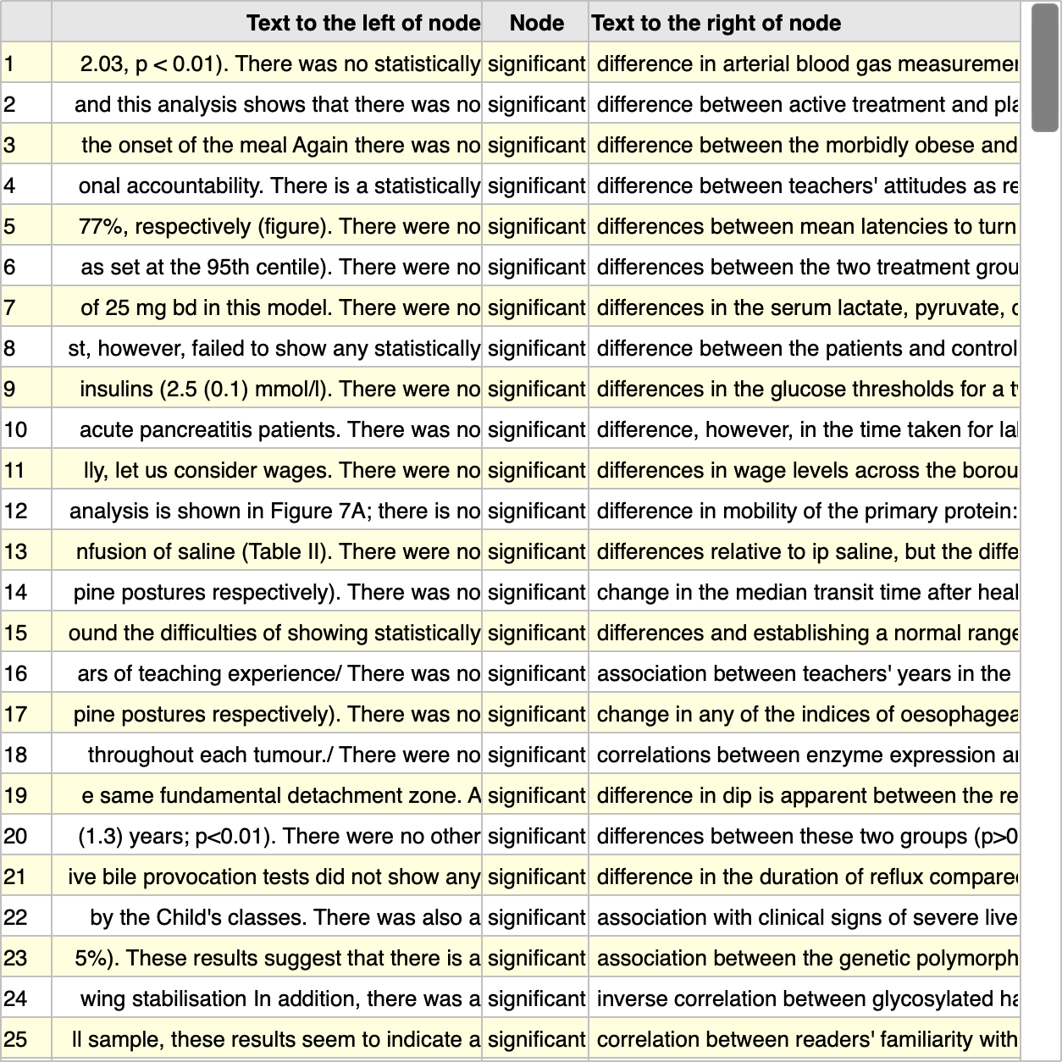

The figure above was created by resizing the app window as shown in the full screenshot below.

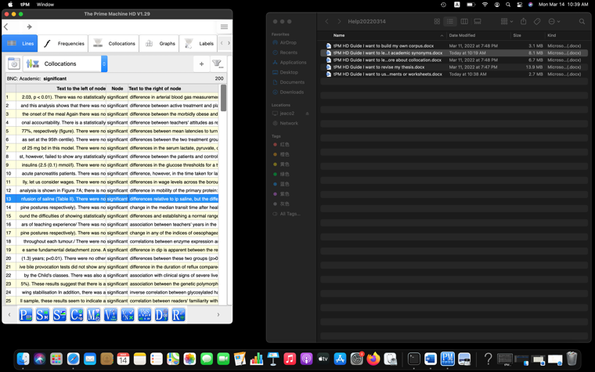

Generally, the smaller the app window, the larger the letters will appear!
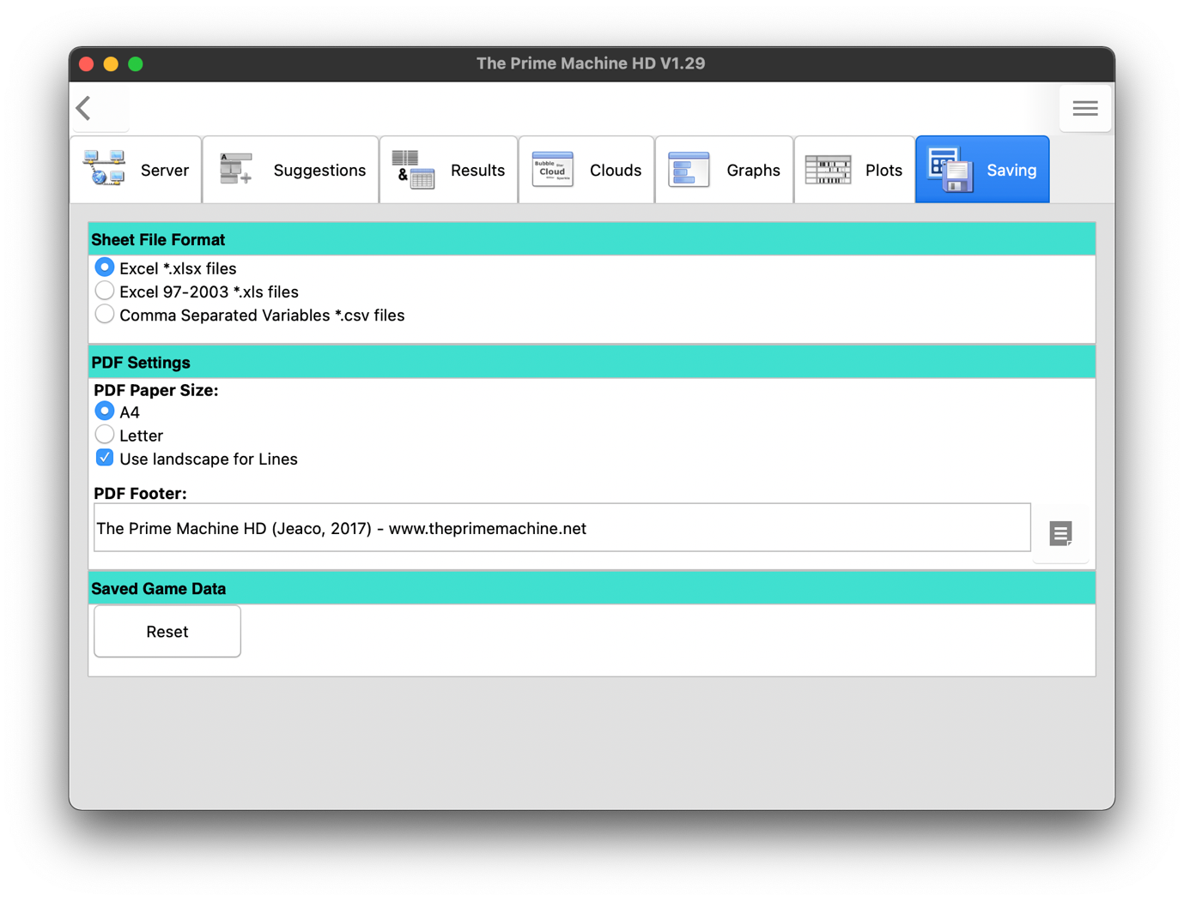
Settings relating to saving or sharing as a spreadsheet or PDF can be found on the Saving tab of the options screen. The default settings will create PDFs with landscape orientation for concordance lines and portrait orientation for other tables. The footer can also be changed.

When saving concordance lines as a spreadsheet, the display settings will determine:
- Whether the wider context or just the sentence containing the node will be included.
- Whether the text category and citation will be included in additional columns to the right.

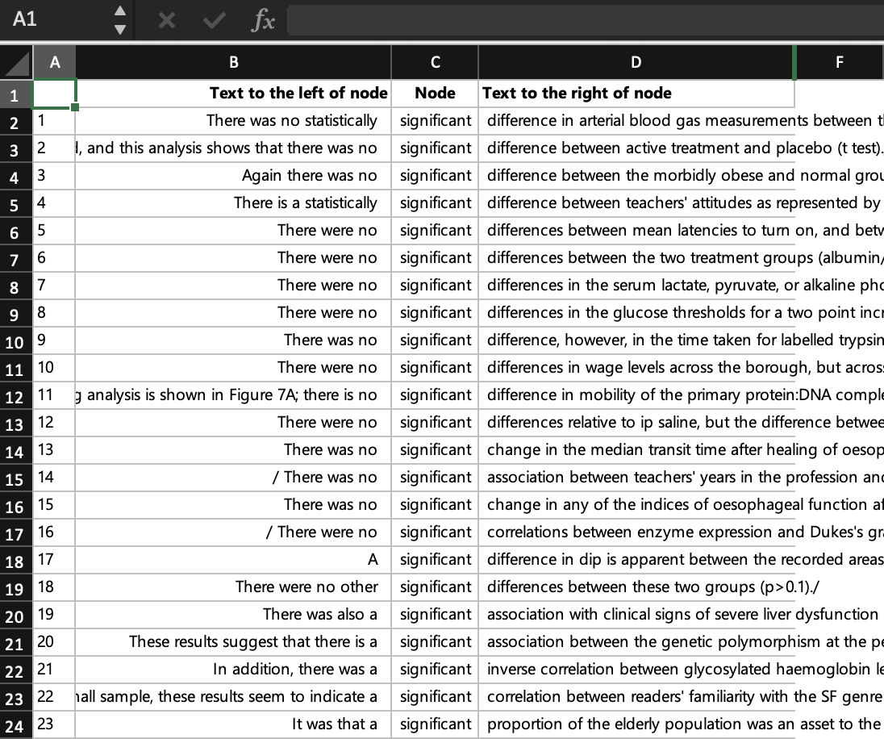
Text categories and citations will appear in these columns if they have not been hidden.
Column B is right-aligned, so if you increase the width, more co-text to the left will be visible,
Step 2: Learn how to filter concordance lines in several ways

If you are using concordance lines for a research assignment, it is quite normal to have figures showing 20, 50, or 100 concordance lines. You may then describe the patterns by referring to line numbers. Atypical examples can also be mentioned. But in some situations, you may want to filter the results to provide a smaller selection. In tPM you can filter the results in several ways:
- Selecting lines manually one at a time or in batches of 25.
- Selecting lines which include words or patterns of letters in the co-text or citation.
- Selecting lines which match various criteria using the lists of features on the Graphs tab.

After the lines have been selected, you can use the filter option to hide those which were not selected, or you can use Filter and Compare to display the selected lines on the left (A) and all lines which were not selected on the right (B).
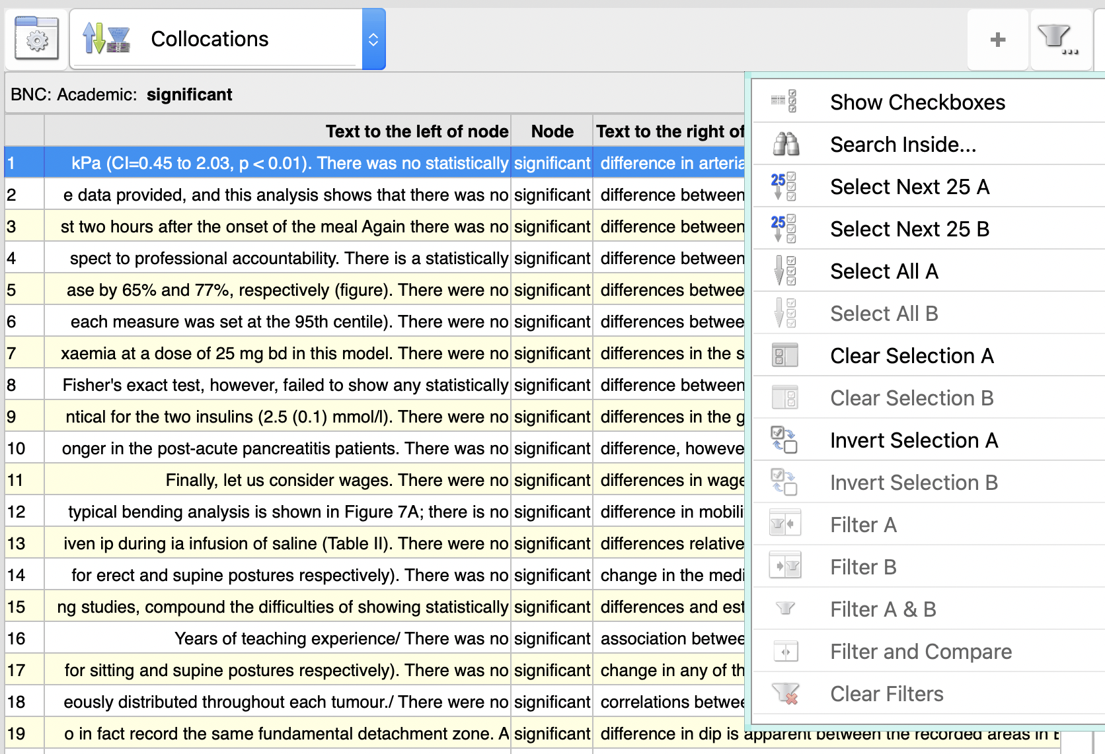

In Full Mode, the lines display has a filter button in the top-right corner. This menu is used to select lines manually, to use the Search inside… pattern matching, and to perform the filtering of selected lines.

The first option - Show checkboxes / Hide checkboxes – will toggle the display of checkboxes to the right of the concordance lines. Using the Select Next 25 A/B buttons will also turn on this feature and select 25 lines starting from the currently selected concordance line. If you select Search inside… a menu will appear as shown below.

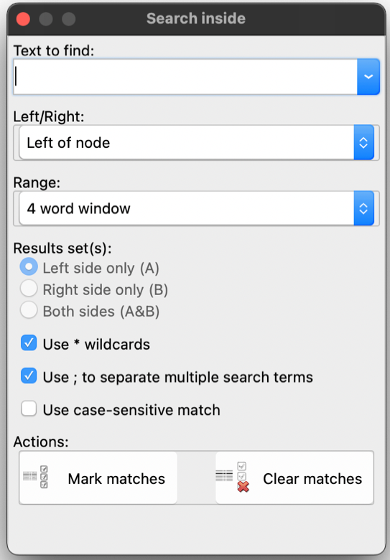
The action can be to tick matching lines or untick them.
Additional settings allow use of * to represent any combination of letters, use of ; between whole words and case-sensitivity.
Decide whether the scope of the search is to the left or right of the node.
The range can be 4 words to the left or right, the extended co-text (whole card), or the text category or text name (citation).
Enter search terms here.
A third way to select lines for readymade corpora, is to use the features on the Graphs tab. For example, to select only the lines where the indefinite article appears to the left of the node, go to the Definite/Indefinite item on the graphs tab, and untick the features you do not want to include. Clicking or tapping on the Mark A button will then select only the lines matching the features.
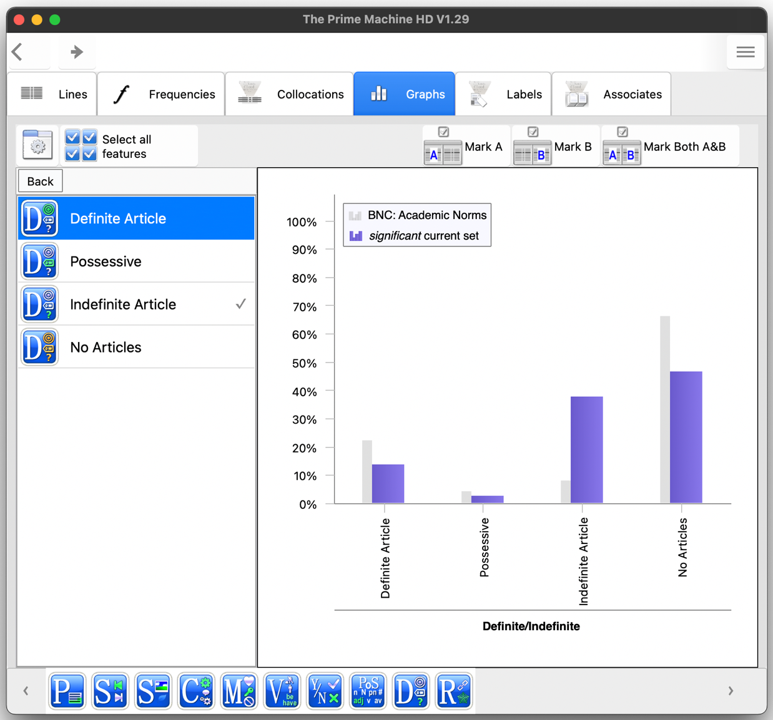
Once lines have been selected, use the filter menu again to select Filter A. When you copy, save or share lines which are filtered, only the filtered items are included.
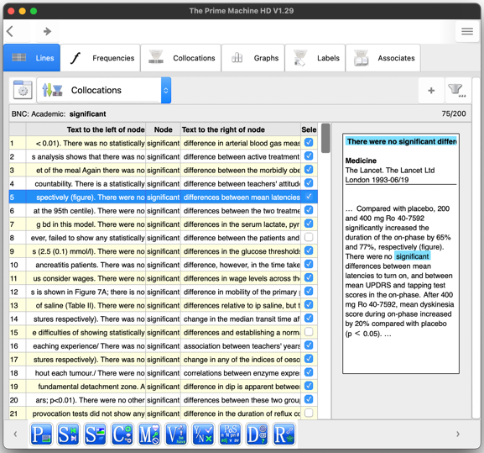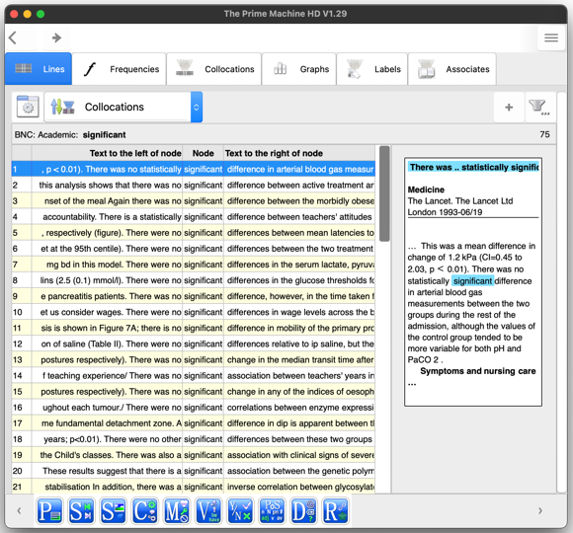

Step 3: Learn how to save concordance cards

The Cards displays can be copied, saved or shared, using the pop-up menu which appears when you double-click, right click or long tap on a card.

The shape of the card will match the display, so resizing the display or selecting the Cards option from the display settings before copying will make a different size and shape. On Windows and macOS, as well as saving the current card, you can save all the cards as images in one operation. The save dialog will ask for a base filename. Each card will then be saved in a separate file. The Wider Context / Sentence Only toggle and the Show/Hide Captions also affect the display of cards.

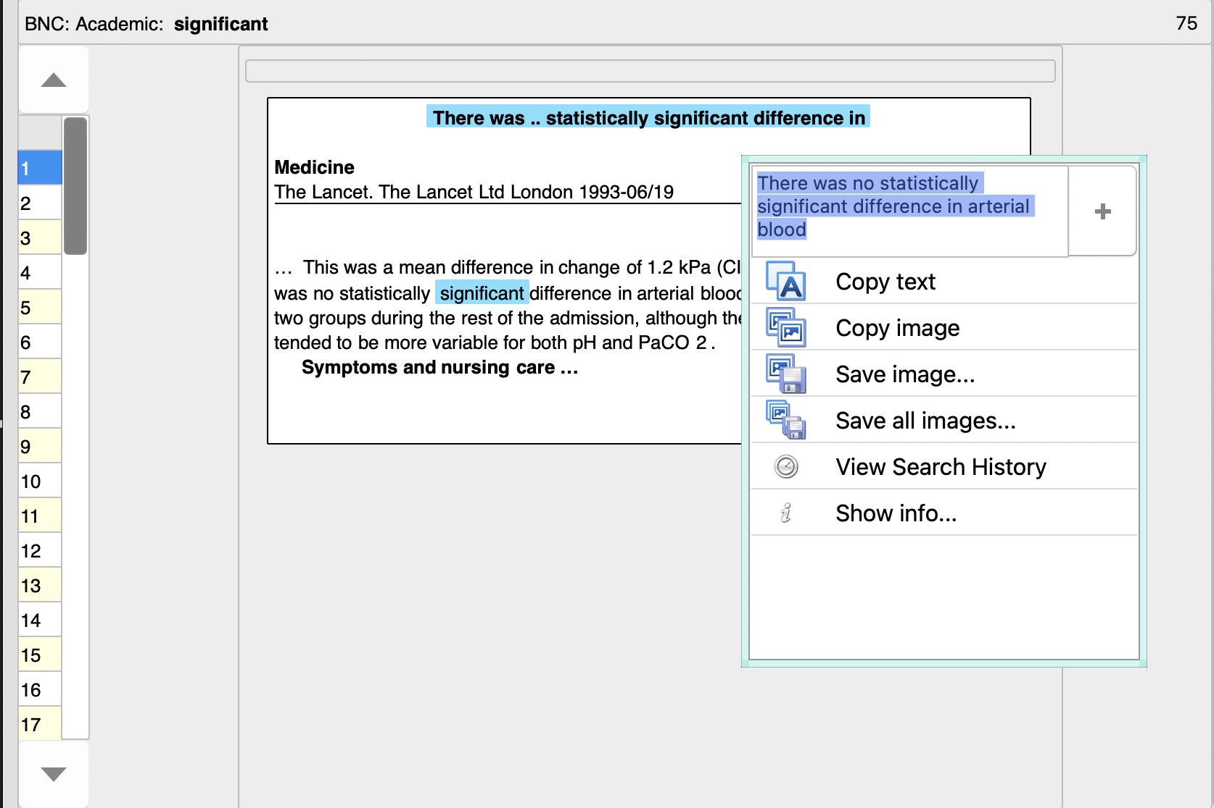
Step 4: Learn how to extract text from concordance lines and cards

As well as copying the concordance line and card displays, it is also easy to copy text from a single concordance line or card.

Except when in Game Mode or when a mask is being used (see page 10 below), at the top of the menu for copying and saving you will see a text box and a + button.

At first, the text box will only show a small extract of the concordance line or card (depending where the line or card was clicked or tapped). If you press the + button, it will increase the amount of text to be copied. Again, this is affected by the display settings, so for example, if you have selected Sentence Only and hidden captions, only the sentence containing the node will be copied from a card.

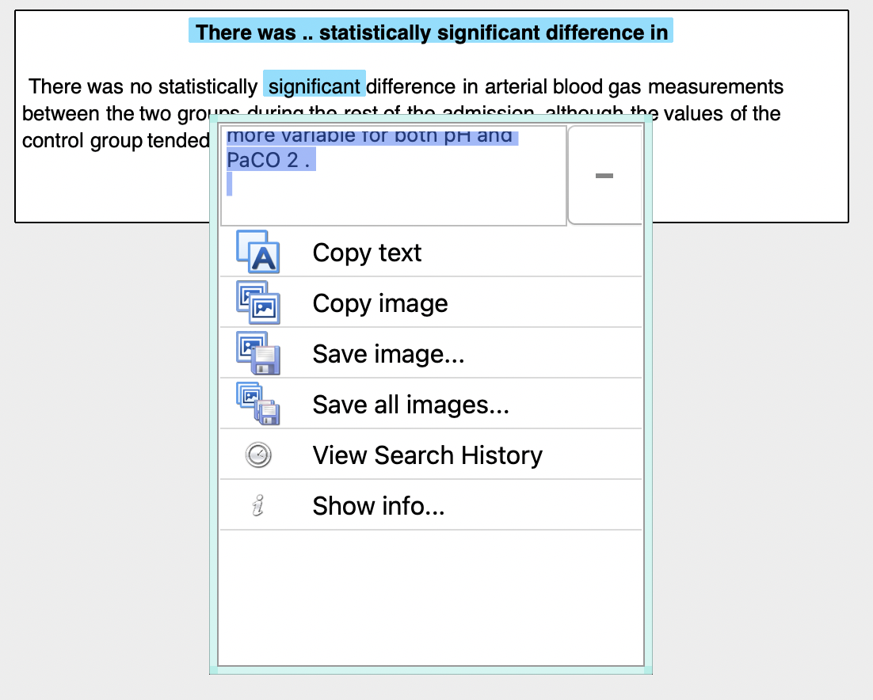

The plain text from the screenshot above would be as follows:

There was .. statistically significant difference in
There was no statistically significant difference in arterial blood gas measurements between the two groups during the rest of the admission, although the values of the control group tended to be more variable for both pH and PaCO 2 .

In linguistics essays and reports, it is common to number examples and indent them.

For example, the text from the example above could be presented as follows:
- There was no statistically significant difference in arterial blood gas measurements between the two groups during the rest of the admission, although the values of the control group tended to be more variable for both pH and PaCO 2 .
BNC: Academic

Step 5: Learn how to make guess the missing word exercise sheets

In Full Mode, you can hide the node word and one word to the left or right using masks which are available from the display settings menu.

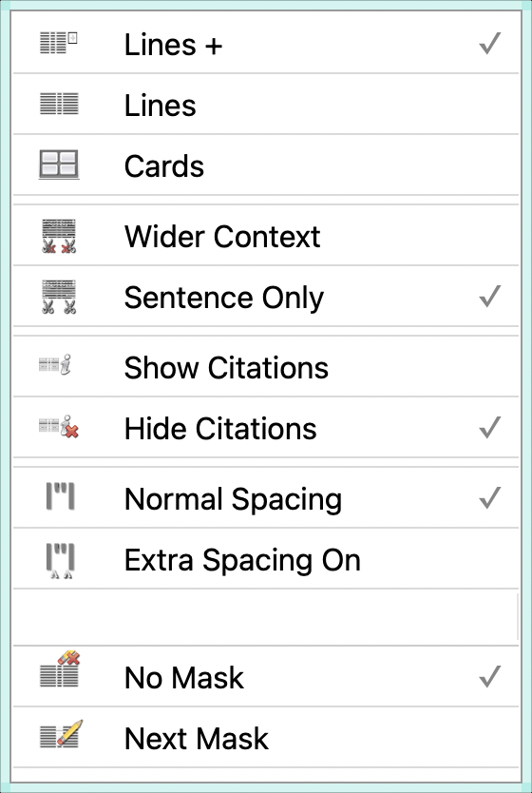
Each time Next Mask is selected, the app will cycle through a list of mask settings.

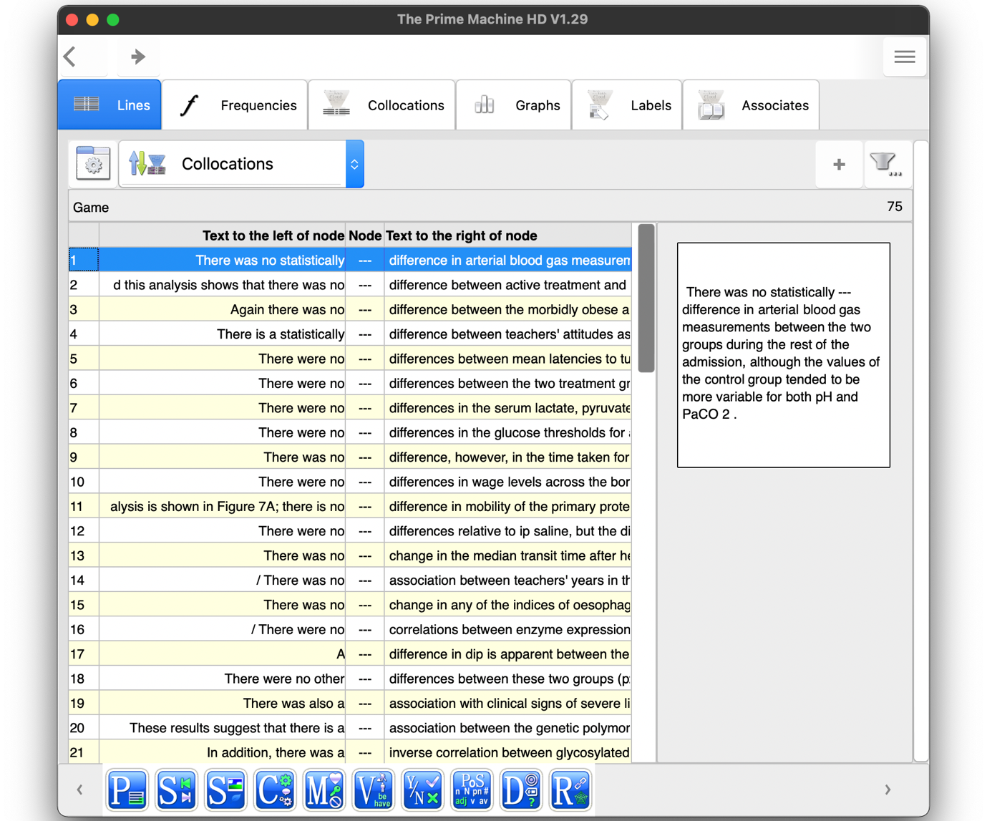
The first mask simply hides the node word in the lines and cards.

As you may want to make worksheets with multi-word items, the other masks provide flexibility.

Full list of masks includes these elements in various combinations:
- Hiding of the Node word
- --- added before the node
- --- added after the node,
- Hiding of one word before the node
- Hiding of one word after the node

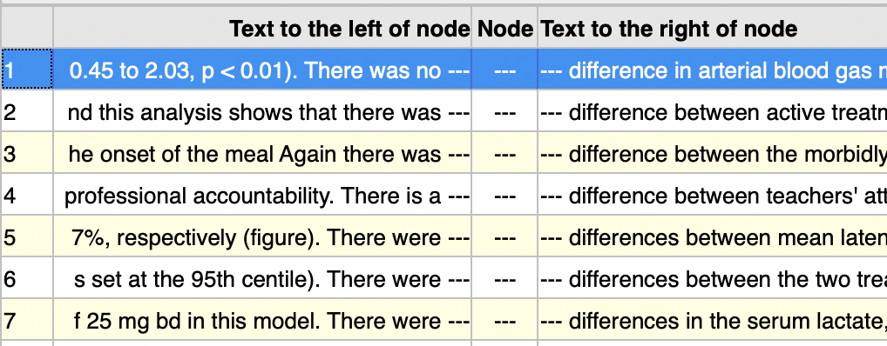

Step 6: Learn about adjusting columns of other data tables.

On some table displays an option to hide or show columns is available. This is particularly useful for tables such as Corpus Statistics, as there are many columns of data.

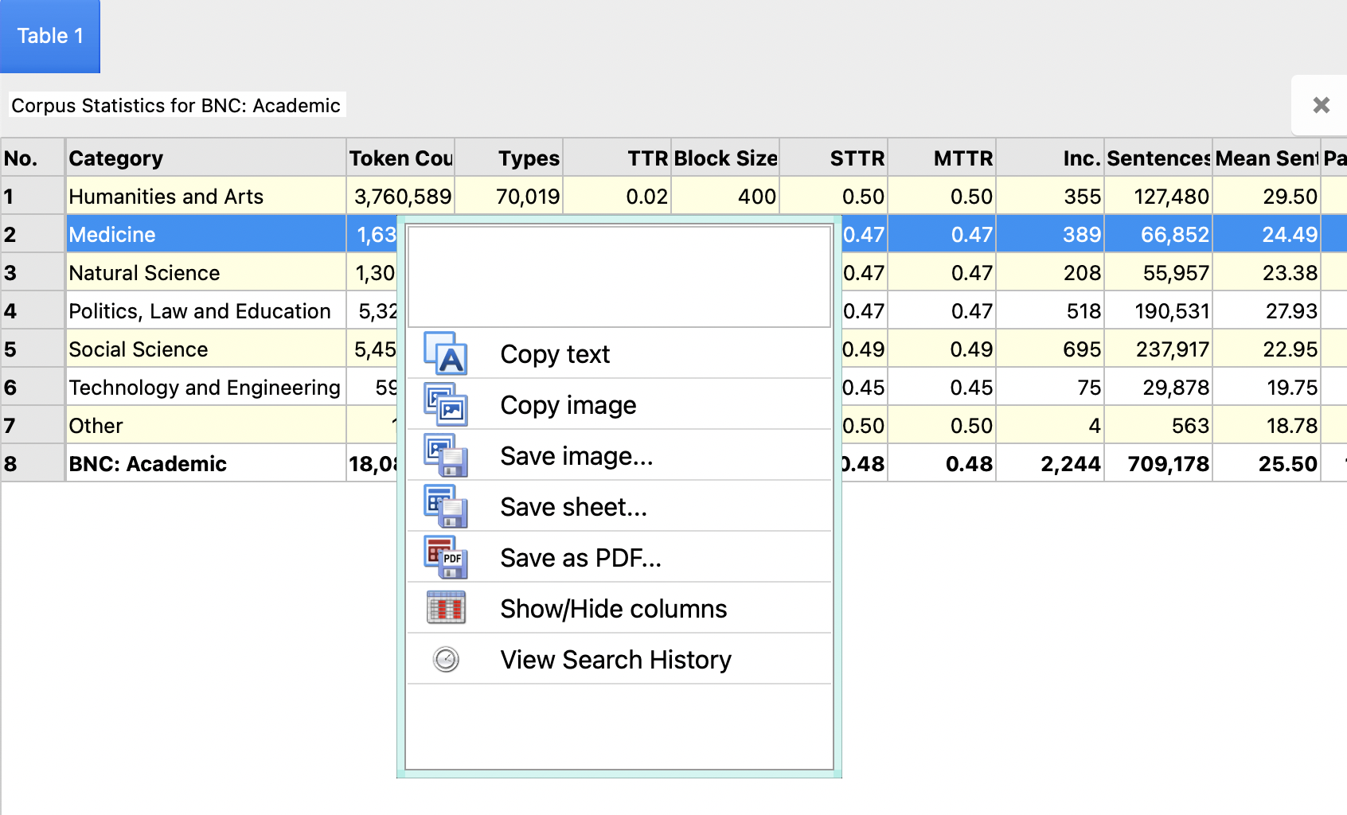

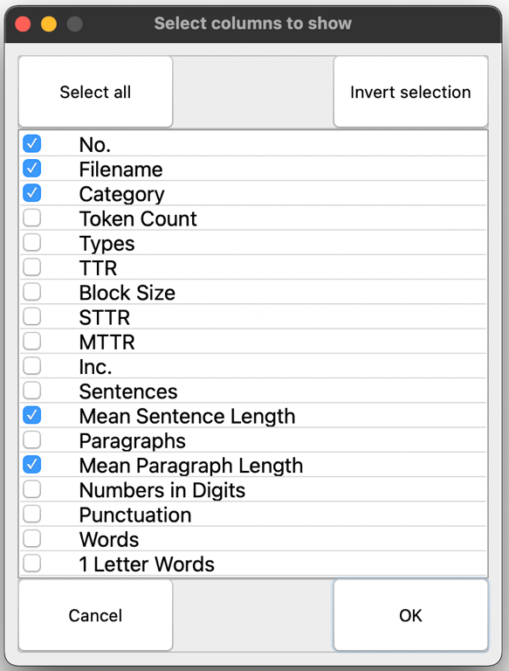
Columns can be re-sized by selecting the column line in the main part of the table, below the header.
Remove the blue tick mark from any columns you do not want to be visible.

After unwanted columns have been hidden, copying, saving or sharing the table will only include the visible columns.

For some of the background to these methods and approaches, please see the tPM Help Selected Bibliography available from https://www.theprimemachine.net/help.html.

Finally, if you use tPM for academic research, please do cite the app in your list of academic references.

Jeaco, S. (2017). Concordancing Lexical Primings: The rationale and design of a user-friendly corpus tool for English language teaching and self-tutoring based on the Lexical Priming theory of language. In M. Pace-Sigge & K. J. Patterson (Eds.), Lexical Priming: Applications and Advances (pp. 273-296). John Benjamins.

Dr. Stephen Jeaco - 杰大海
www.theprimemachine.net

This work is licensed under the Creative Commons Attribution 4.0 International License. To view a copy of this license, visit http://creativecommons.org/licenses/by/4.0/ or send a letter to Creative Commons, PO Box 1866, Mountain View, CA 94042, USA. If you use this document, please include a link to the tPM Help Selected Bibliography available from https://www.theprimemachine.net/help.html.

First published: Thursday, 17 March 2022

Last updated: Thursday, 17 March 2022

