The Prime Machine HD
Getting Started and app Overview for ELT

What it is:
The Prime Machine HD is an English language learning, teaching and research tool, designed to provide users with a multitude of examples from corpus texts and additional information about the contextual environment in which words and combinations of words occur.

Users can type in words or phrases and view concordance lines and other corpus data. It has research tools for more advanced concordancing, and there are also DIY corpus tools allowing small collections of your own English texts to be analysed and compared with the ready-made online corpora. With tPM you can:
- Get hundreds of examples for words and phrases and view them on your phone, tablet, laptop or desktop computer;
- See how synonyms and related words are used differently;
- See frequency data and collocations;
- Analyse a sentence, a text or a collection of texts using the DIY Text Tools.

Where to get it:
- The best place to get tPM is from an official Store:

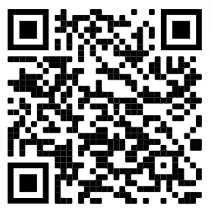 | 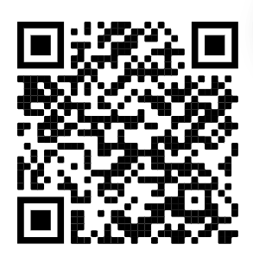
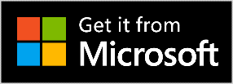
It is free for everyone!

Windows and Android users can also download the App directly from the website: https://www.theprimemachine.net

Opening the Application
When you first use The Prime Machine, you almost certainly will want to connect to the server to access pre-prepared corpora and resources. There are two main views for the search screen – Simple Mode and Full Mode. The Full Mode includes additional tabs and features for corpus research and DIY corpus work.
Simple Mode
Full Mode

Here is a list of the main tabs and their purposes:
Simple Search | Enter a word, collocation or phrase to request results from the server.
Break Down | Enter a phrase or sentence and break it down into words and combinations of words. Frequencies of these combinations can then be checked in the corpus, along with suggestions for reformulations. The collocation strength between each word can also be colour-coded using the currently selected readymade corpus as a baseline.
Compare Two Corpora | Look up a word or phrase in two corpora at once. Then view the results side by side (screen size permitting) or flip between them using the forward/back buttons on the results screen.
History | Save results from your searches to a file for viewing offline later or re-open previously viewed results. On iOS and Android these files can be shared and opened through the Share or Open with functions of your device’s File manager app.
Research Tools | This tab opens a new set of tabs for a variety of research-oriented corpus work using the readymade corpora held on the server.
DIY Tools | This tab opens a new set of tabs for a variety of corpus work using your own DIY texts. These tools can allow you to compare your DIY corpus with a readymade corpus or other DIY corpora.

Decide on the mode you want to use and then click Connect.

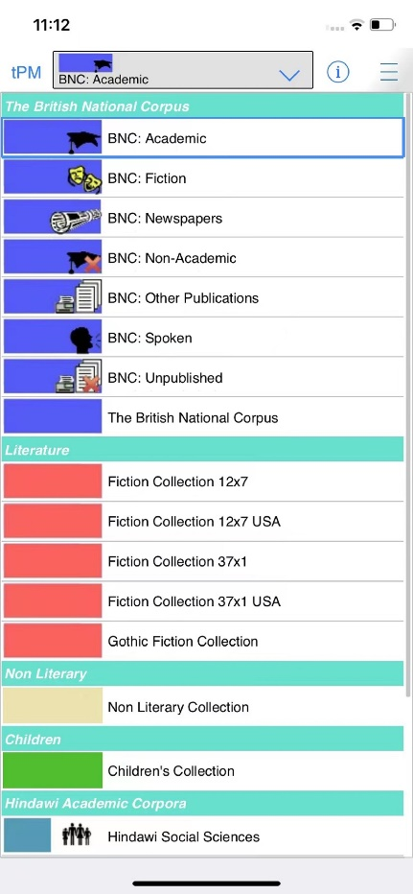
Choosing a corpus
For academic work, the BNC: Academic corpus will be a good choice. This is the default corpus and will already be selected each time you open the app.
If you tap the drop-down menu, you will be able to see a choice of other corpora which are available.

Looking up words and phrases
The main search screen allows you to enter one or two search queries at a time.
If you enter a word or phrase and tap the “hamburger” menu inside the search box, suggestions will appear.
You can see the number of examples in the currently selected corpus.
You can also see collocations, other word forms and words with a similar meaning.
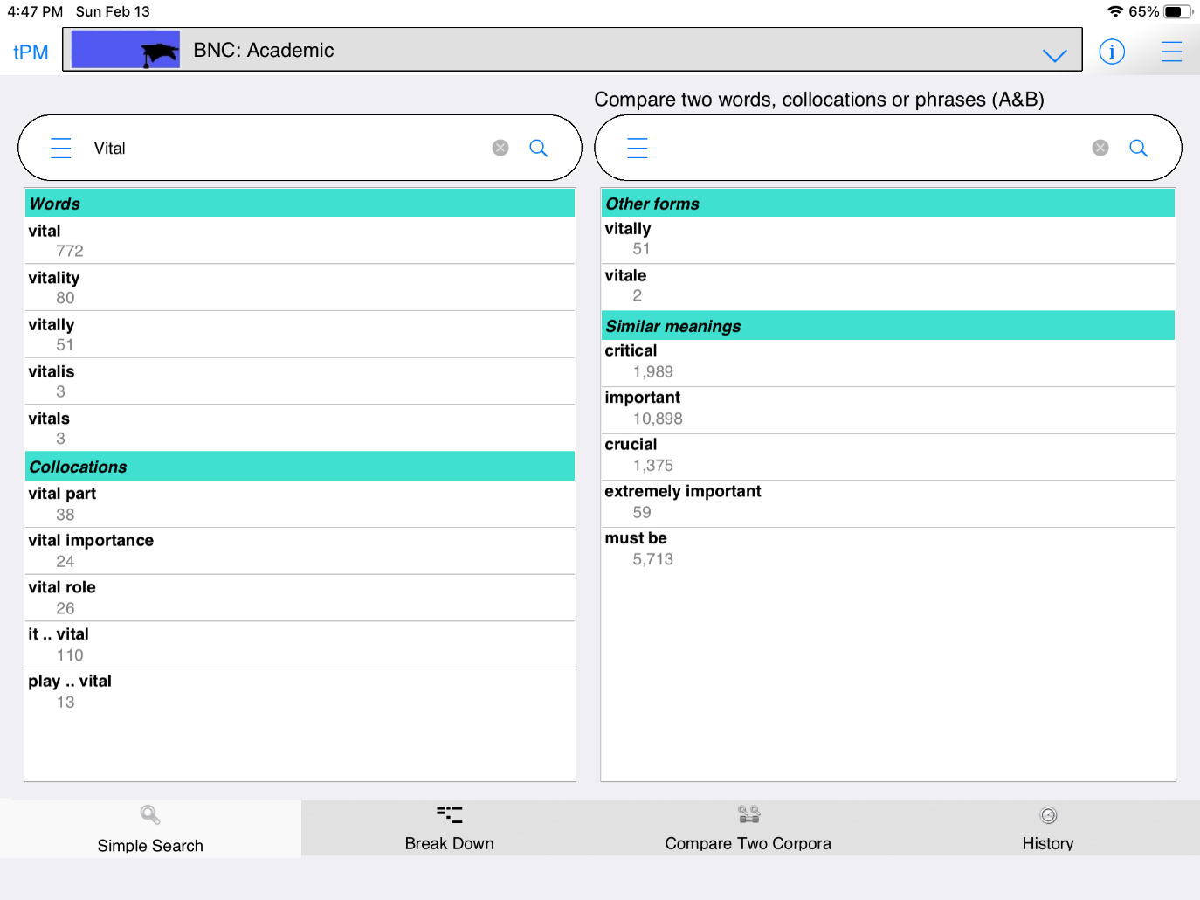
Exploring results
The Lines tab gives you concordance lines and concordance cards. The concordance lines can be sorted in a number of different ways. The default method for sorting the lines is to put lines containing strong collocations at the top. When you tap or click on a concordance line, the card on the right will show the wider context of that example.
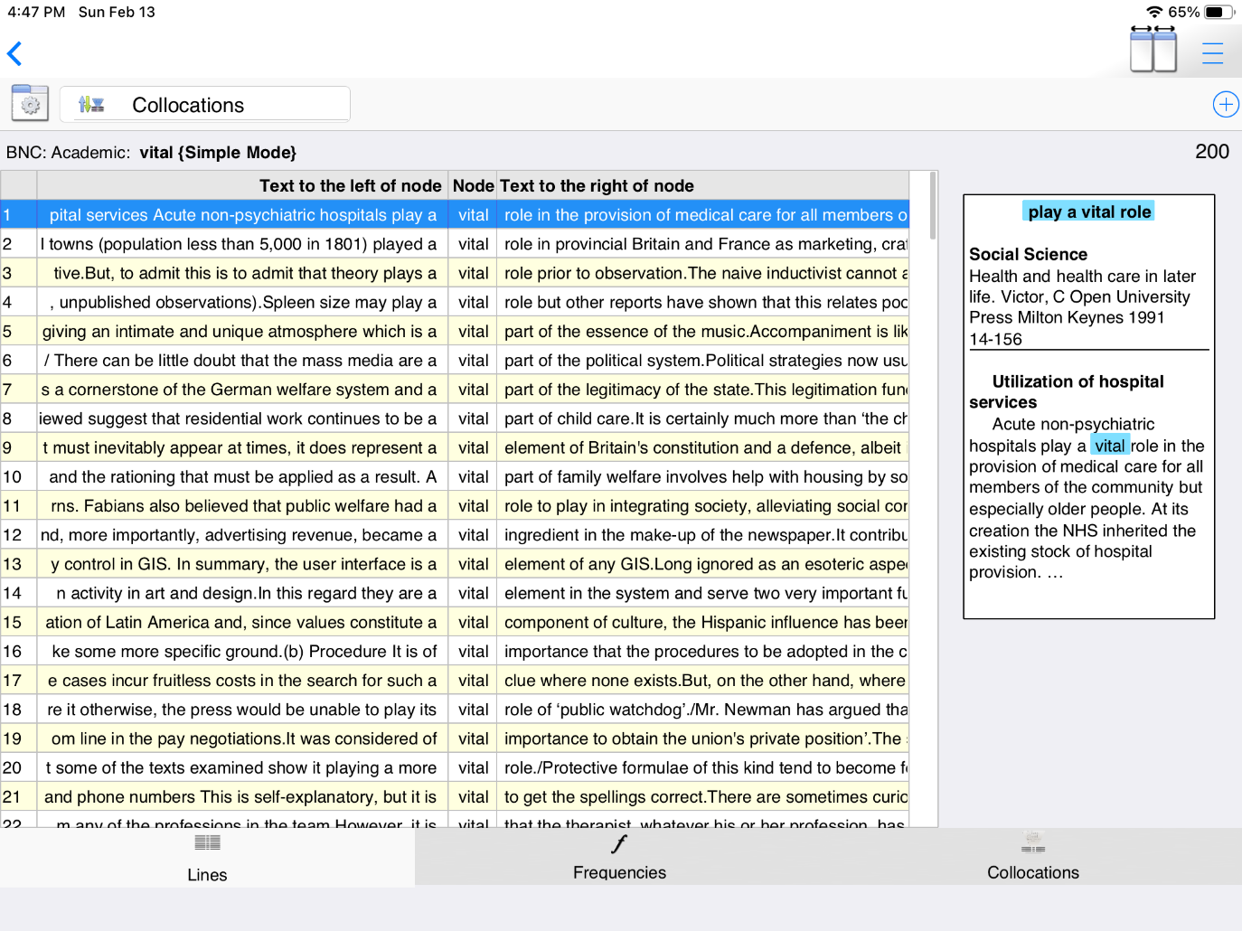
The Frequencies tab has several ways to present frequency data.
The Collocations tab shows how the word fits into multi-word units.
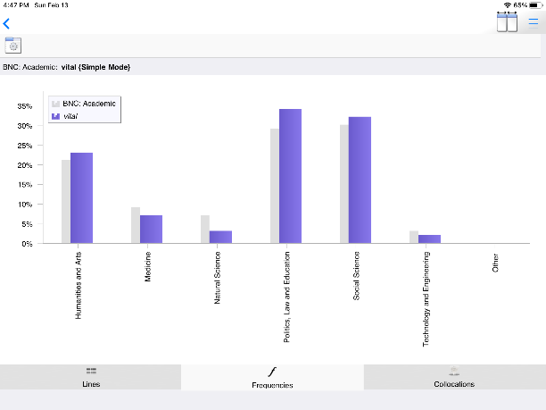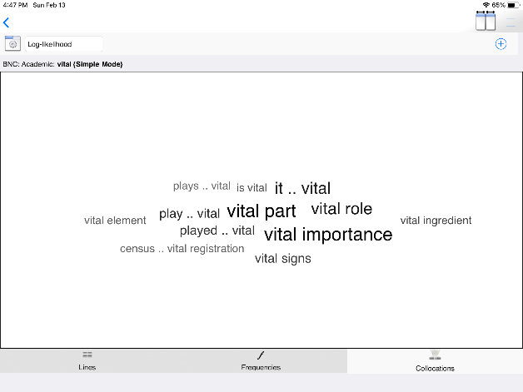

DIY Text Tools
You can also build your own corpus.
On iPhone, iPad or Android Devices:
- Browse files on your device using the device’s file manager or other apps.
- Select a single file or ZIP.
- Share or use Open with to share these with tPM HD.
- tPM HD will launch if it is not already running.

On macOS and Windows you can use the Open button or drag and drop files into the drop zone.

With DIY Text Tools you can get:
- Corpus statistics
- Key words
- Vocabulary profiling
- KWIC & Collocations
- Clusters / n-grams
- Side-by-side comparisons
- Collocation highlighting

Game Mode
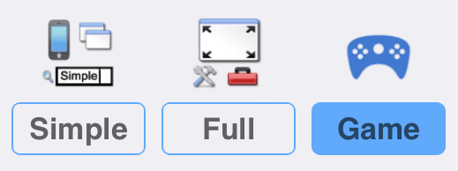
Game Mode provides a different user interface, giving you a list of groups of words to study before you take a challenge and try to guess which word matches a set of concordance lines.

How to play
1. Choose a game:
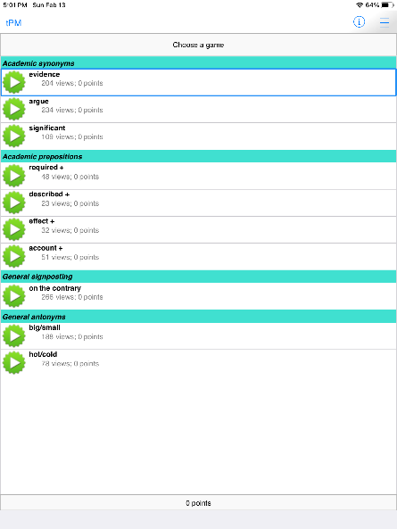
2. Open the words in the group one by one, looking at the concordance lines and thinking about the patterns you see.
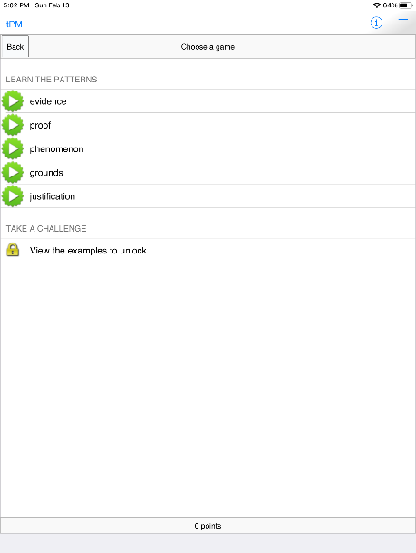
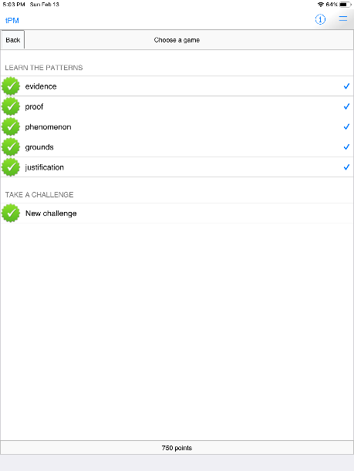
3. When you have viewed all the lines, the Challenge will unlock.
4. Decide how confident you are that you will be able to guess each word correctly.

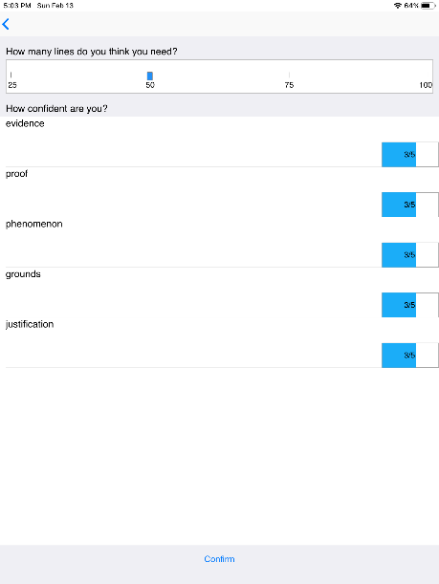
5. Look at the set of concordance lines and guess the missing word.
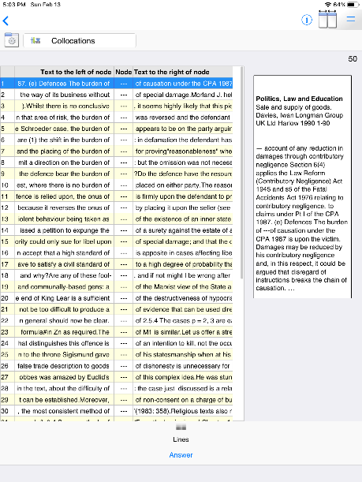

Use tPM to learn and teach English
Students:
- Find and study examples of how words are used in different contexts;
- See for yourself how synonyms and similar words are used differently;
- Explore different text types and consider subtle differences in meaning.
Teachers:
- Bring the power of corpus linguistics into your classroom;
- Give examples to your students to help them notice and learn collocations and grammatical patterns;
- Analyse texts using a range of readymade online corpora as a baseline, and explore keywords, wordlist statistics and collocation matches.
- For Dissertation editing: have students load their dissertation as one DIY corpus and use their sources or a readymade corpus for comparison.
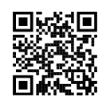
Dr. Stephen Jeaco - 杰大海
www.theprimemachine.net

This work is licensed under the Creative Commons Attribution 4.0 International License. To view a copy of this license, visit http://creativecommons.org/licenses/by/4.0/ or send a letter to Creative Commons, PO Box 1866, Mountain View, CA 94042, USA. If you use this document, please include a link to the tPM Help Selected Bibliography available from https://www.theprimemachine.net/help.html.
First published online: Thursday, 17 March 2022
Last updated: Thursday, 17 March 2022

