The Prime Machine HD Guide
I want to … learn more about academic synonyms
If you are an undergraduate or postgraduate student, using English as the language of instruction, you will need to develop your academic writing skills. As well as learning to use academic vocabulary to express your own ideas, the use of academic synonyms is important when paraphrasing and summarizing ideas from others. If you choose words just based on a wordlist or a dictionary entry, or if you try to find similar words using a thesaurus, you will probably discover that your EAP teacher and subject professors find that your expressions seem unnatural or awkward or simply aren’t the right word choices. This guide will explain the steps you can take to deepen your knowledge of academic synonyms through game activities and analysis using The Prime Machine HD corpus tool.

Steps to complete:
- Learn how to read concordance lines and other corpus data by playing some games about academic synonyms.
- Learn how to use the search support features to help you find words and word forms to compare.
- Use tPM’s corpus tools to explore different aspects of words with similar meanings.

This approach can help you:
- Learn how to notice the typical patterns of usage of different synonyms.
- Discover common collocations of words with similar meanings.
- Find differences in the grammatical patterning associated with different synonyms.

What you’ll need to get started:
- The Prime Machine HD for Windows, macOS, iPad, iPhone or Android (available free from https://www.theprimemachine.net/ )
- Some words to inspire your exploration after you’ve tried the games.
- Patience, enthusiasm and an open mind!

Looking at your use of language through linguistic spectacles
You don’t need to be a student of linguistics to be able to analyse the patterns of use of language (but of course if you’ve studied linguistics you can draw on your linguistic knowledge). When you complete an academic assignment, you are essentially showing to your professors, the institution and the world that you are becoming a member of an academic community – a community which communicates using academic conventions and through academic language. Your use of academic vocabulary and specialist terminology reveals your experience reading and hearing these words and phrases as they are applied in your specialist discipline.

Are you ready to become a language detective?
To make the most of the approach described here, you will need to try to think about your word choices as a detective might look at clues. As well as being an amazing expert in detection, Sherlock Holmes is also remembered in the stories as being an expert in disguise.
- As a detective, can you look at a hundred examples of a word or phrase and pick out some of the patterns which occur?
- As a detective, can you look at the context and co-text of examples from a corpus to see deeper meanings and typical uses of words?
- As an expert in disguise, can you dress-up your own writing, so as to blend into the norms and expectations of expert language users?

Getting started
The best place to get The Prime Machine HD (tPM) is from an official store. It is free!

Windows and Android users can also download the App directly from the website: https://www.theprimemachine.net
The main ‘hamburger’ or 蒸笼menu in the top-right corner allows you to connect and change mode.
When you first use tPM, you almost certainly will want to connect to the server to access pre-prepared corpora and resources. There are three modes: Simple Mode, Full Mode and Game Mode. The Full Mode includes additional tabs and features for corpus research and DIY corpus work.

Simple Mode
Full Mode

Game Mode
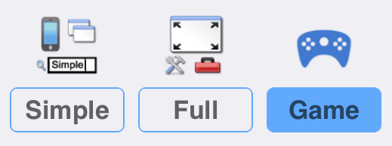
Game Mode provides a different user interface, giving you a list of groups of words to study before you take a challenge and try to guess which word matches a set of concordance lines. One of the groups of games is Academic Synonyms.

Step 1: Learn how to read corpus data using tPM Game Mode

How to play

1. Choose Game Mode before connecting to the tPM Server. Then Connect.

2. The first time you try it, you will be shown the instructions for the game.

3. Choose a set of words from one of the games listed. In this worksheet, we are interested in academic synonyms, so select one of the words from this first group.

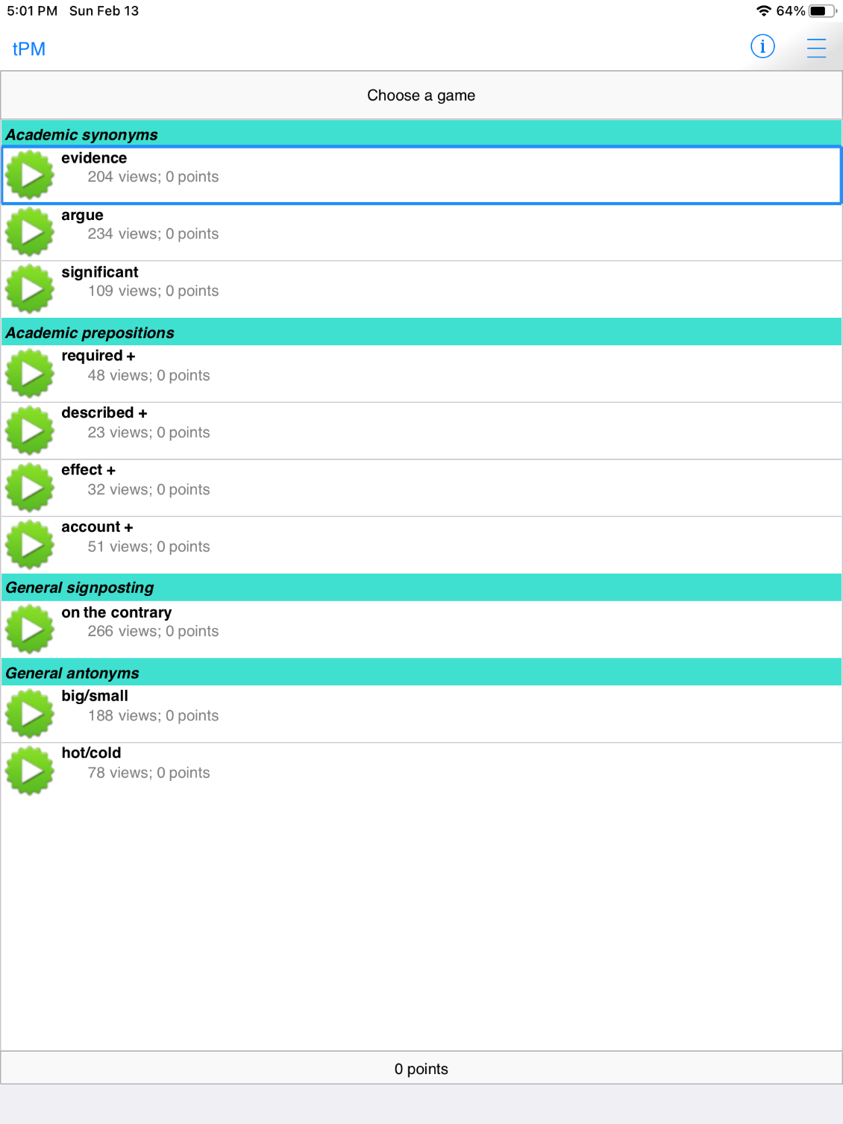

4. When you have selected a game, you will see a submenu containing the words you have to learn. Open the words in the group one by one, looking at the concordance lines and thinking about the patterns you see. This is your chance to try to notice and remember the patterns of usage for each of the words.

5. When you select each word, 200 examples will be downloaded from the server. The displays for learning the words are the same as when you look the words up in Simple Mode.
You can sort the lines in different ways to help you notice patterns.

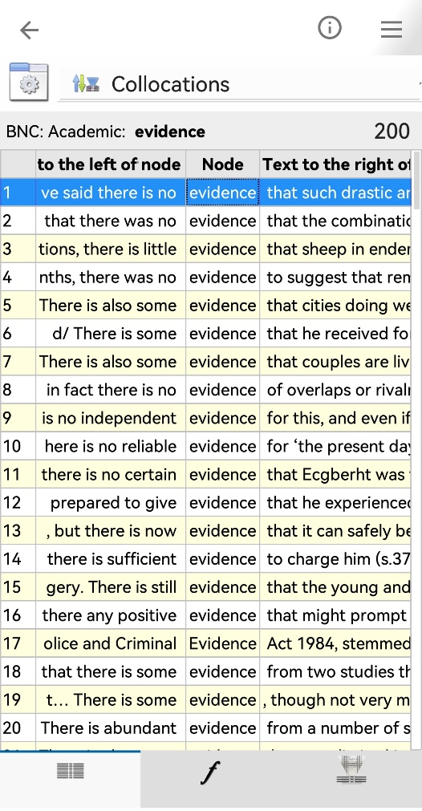
This menu button allows you to change the display settings for the current tab of results.
When learning words in Game Mode there are three kinds of data to view: Lines, Frequencies and Collocations.
This shows the number of examples already downloaded.
On a wider display (like this iPad), you can see a concordance card showing more information about the currently selected line.

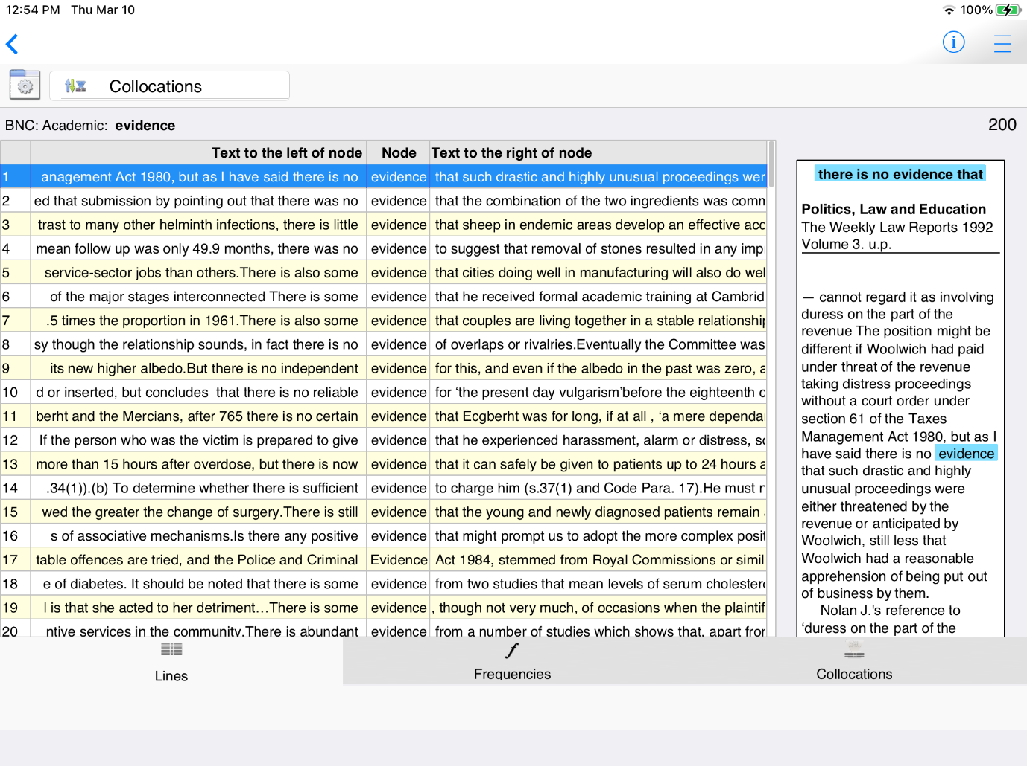
Lines +

On narrower displays (like this Android phone) you can view either lines or cards.
On all devices, switch between Lines + (if space allows), Lines and Cards using these settings.

Other useful settings include just showing one sentence for each hit and hiding the citations.

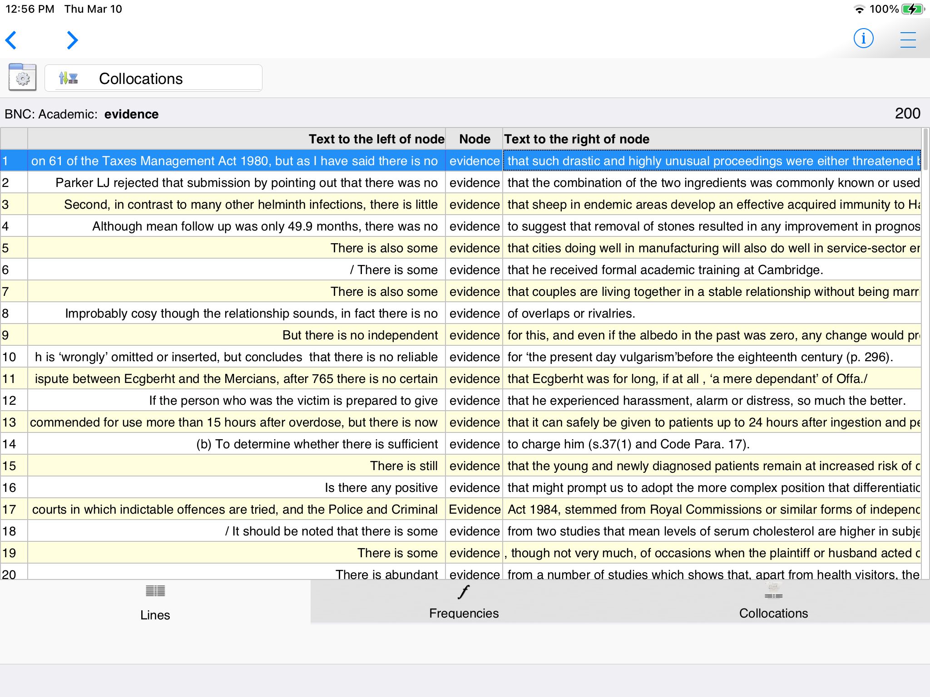
When Sentence Only is selected, you can see if the word occurs near the beginning or end of sentences easily.
Lines
This shows the kind of text from which this example comes with reference information below.

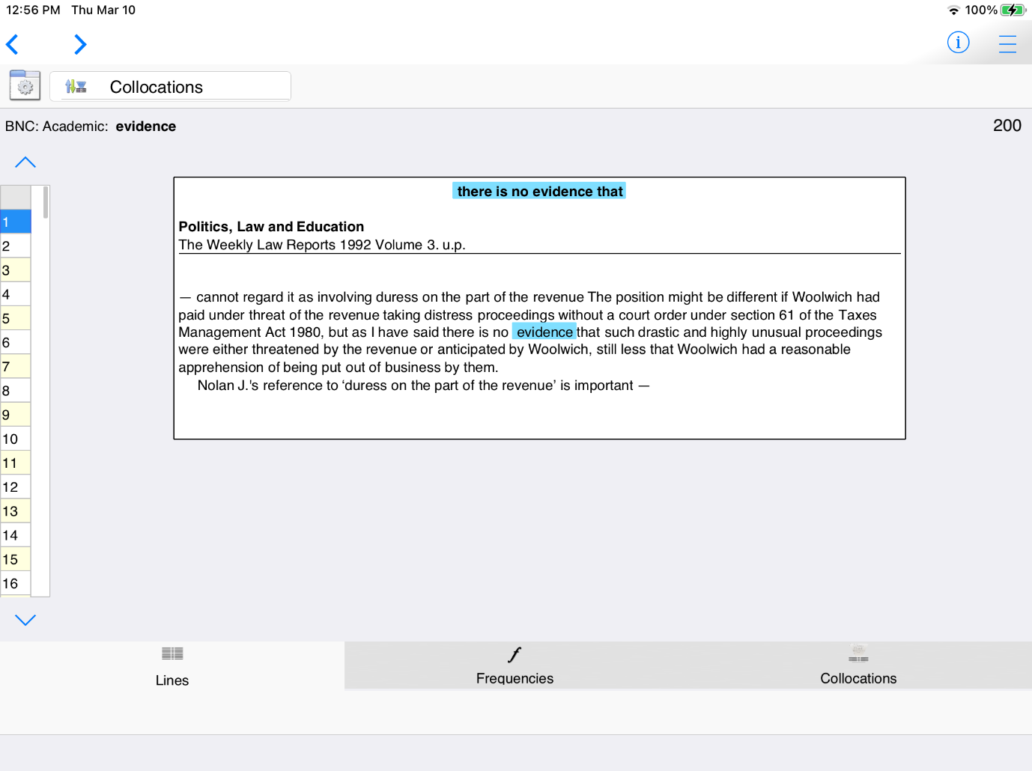
You can navigate through the examples using the sidebar.
At the top of the card you can see strong collocations near the word of interest.
The card shows up to one sentence before and after the sentence containing the hit. Text is displayed with paragraphing.

Cards
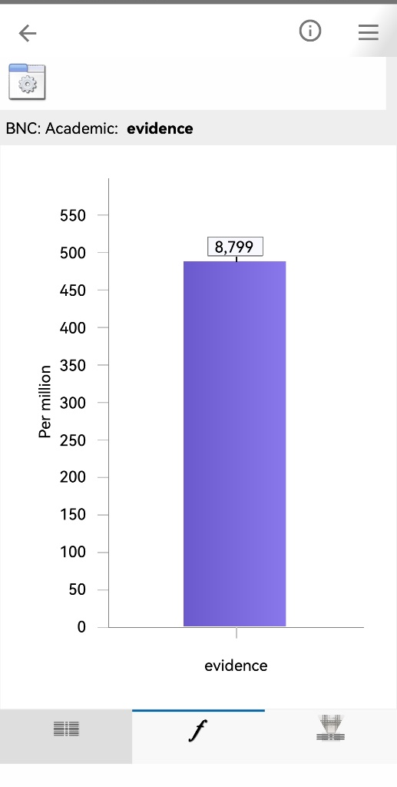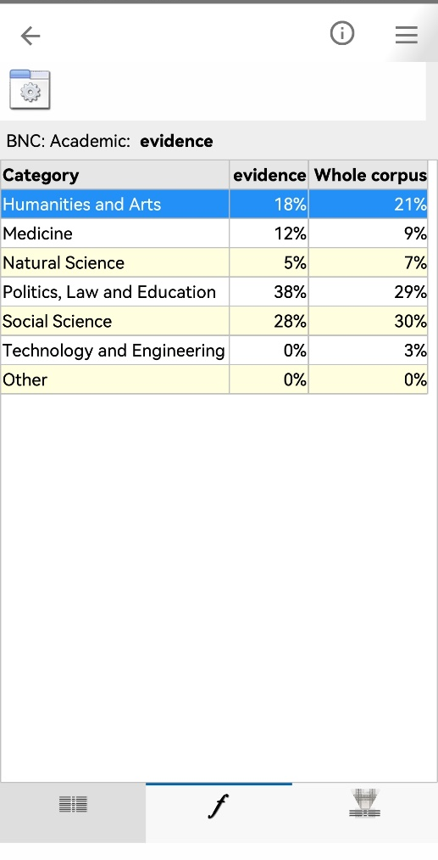
Data can be shown as graphs or tables.
The Frequencies Tab shows various kinds of information about the number of hits in the corpus, the frequency per million words and the distribution across different text types

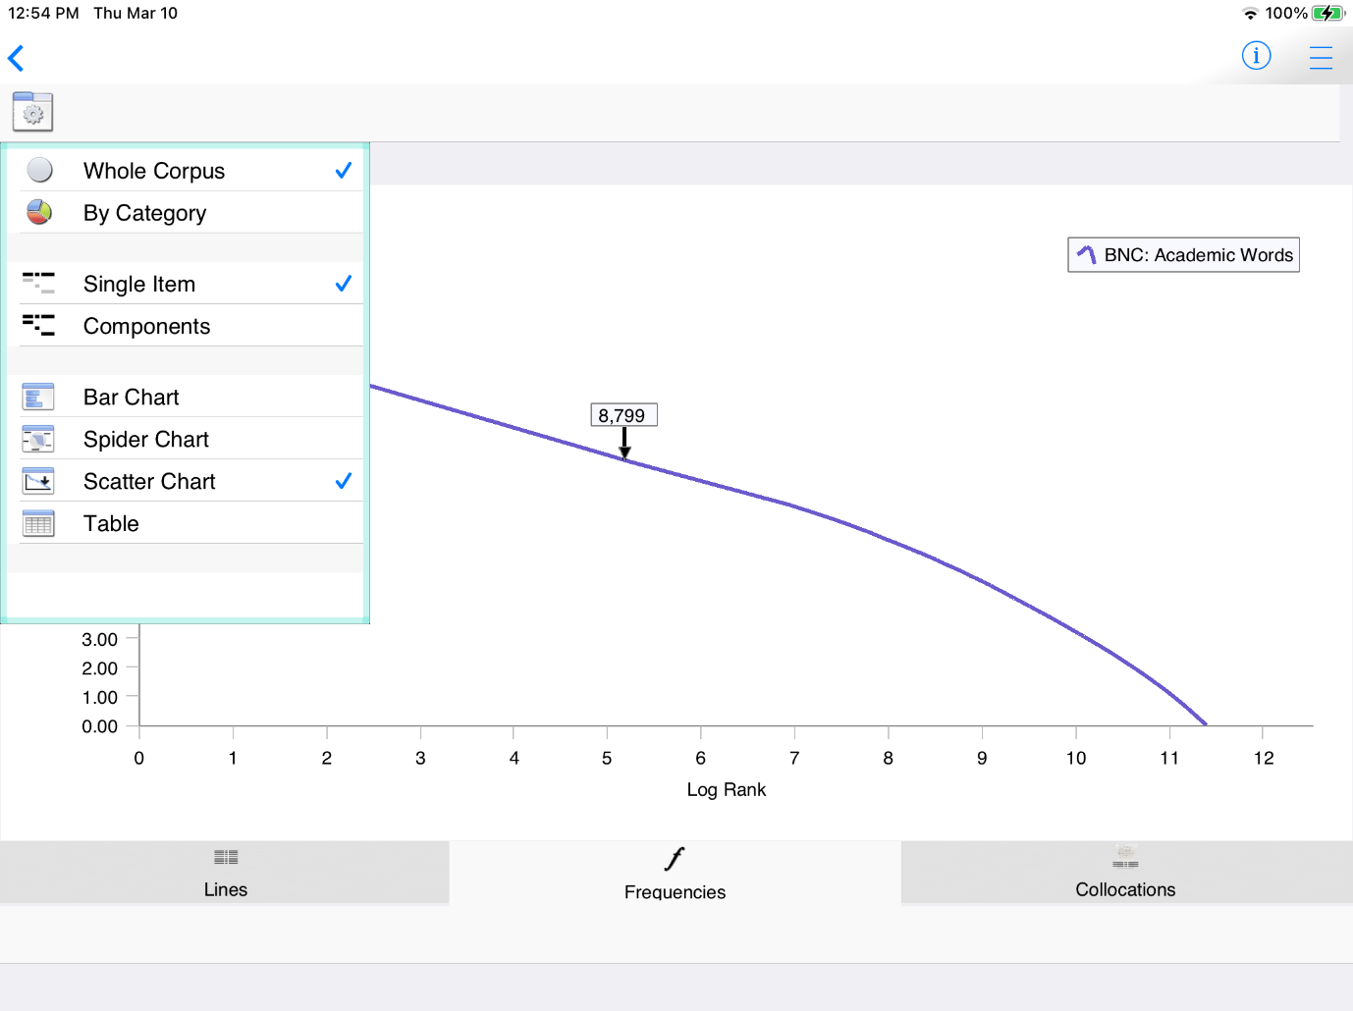
Clicking or tapping on the legend will move it to different positions.
This display settings button allows you to change views.

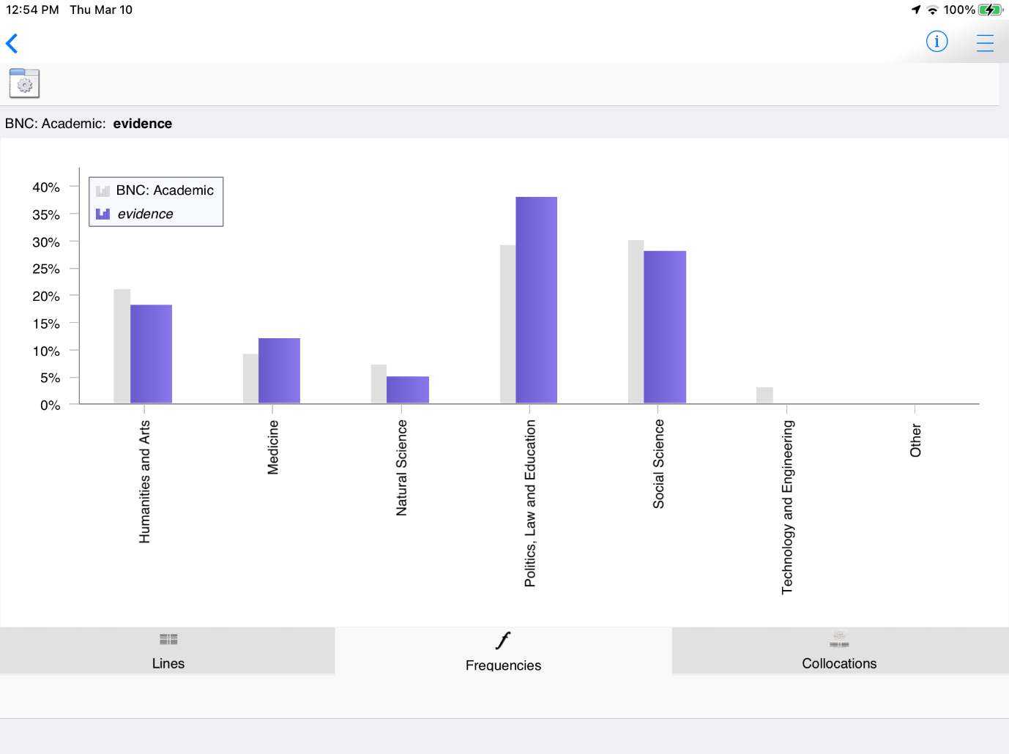
On this display, the grey bars show the proportion of all words in each text category.

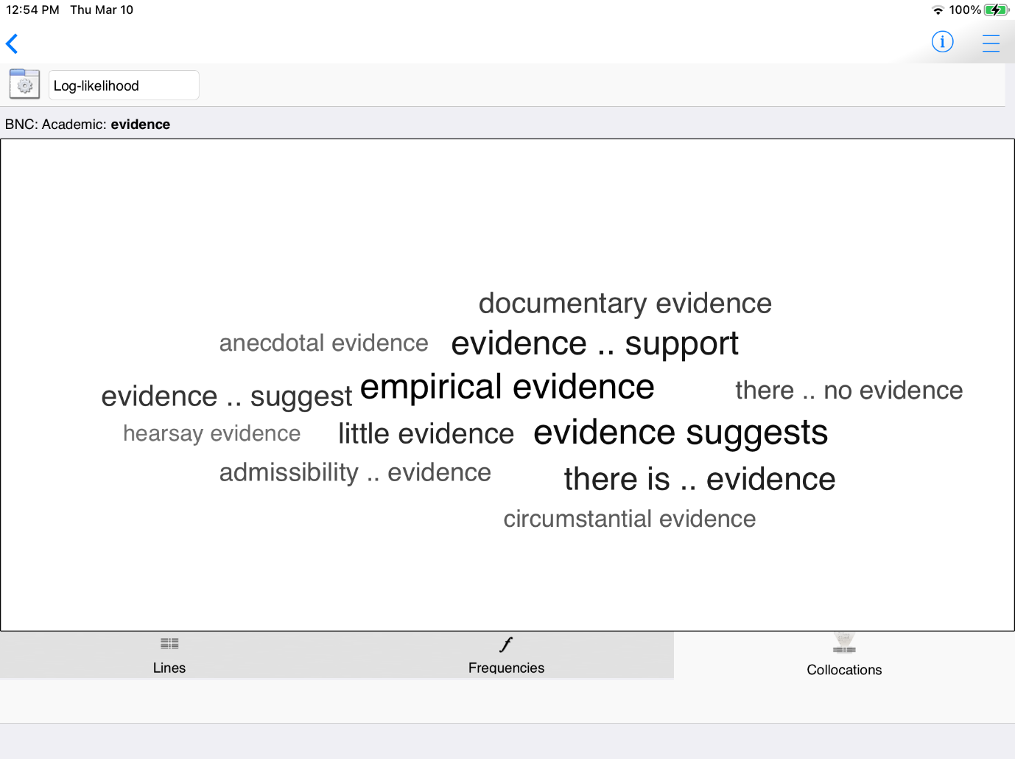
The Collocations Tab shows the word partnerships – the combinations of words which go together naturally in the corpus.

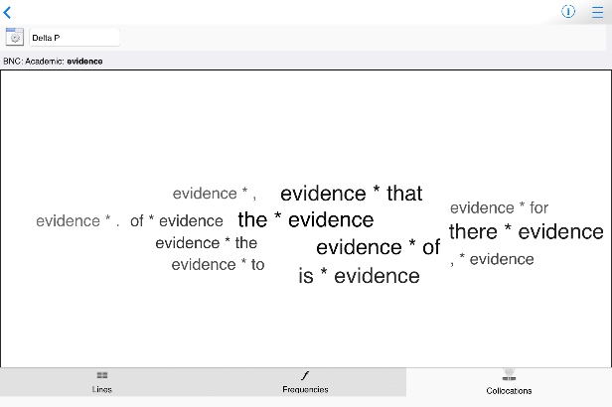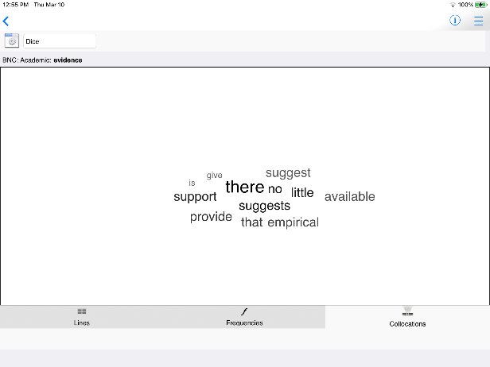

The menu next to the display settings button allows you to choose different statistics.
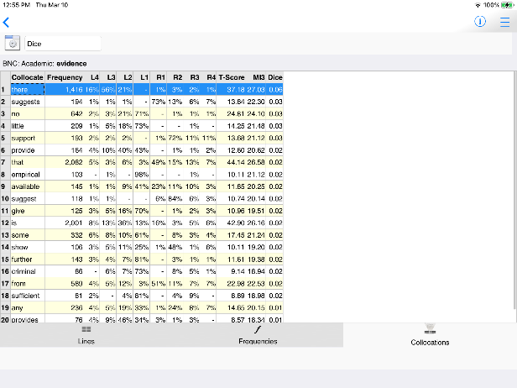

Different statistical measures can be used to create lists of collocations, based on the frequencies of the words near each other and apart. You can also view lists of collocations as tables.

6. When you have viewed concordance lines for all the words, the Challenge will unlock.

7. Each time you take a new challenge, decide how confident you are that you will be able to guess each word correctly.

The more lines you have, the easier it will be to guess, but the fewer games you can play overall.

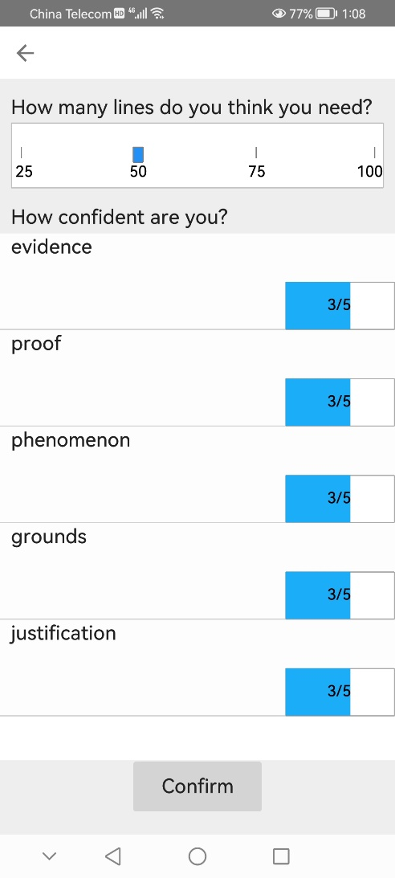
If you slide the confidence down to 1/5, you will get fewer points for a correct answer when this item is the correct answer, but you won’t lose so many points when you guess incorrectly.
If you slide the confidence up to 5/5, you will get more points for a correct answer, but face a heavier penalty if this is the missing word and you guess incorrectly.

Tips:

- Synonyms often have different collocations; if you learn the strong collocations, you should see some of these in the lines at the top (when the lines are sorted using Collocations – the default).
- Synonyms often have different grammatical patterns. Although they may all be the same word class, some nouns may be used with the or this, while others may be used with a, an or some. You may also find differences in use of modal verbs or prepositions, for example.
- If you find the challenge too hard, go back and read more examples of the words by selecting them from the Learn section. You can continue with the same challenge again later.
8. Look at the set of concordance lines and guess the missing word.

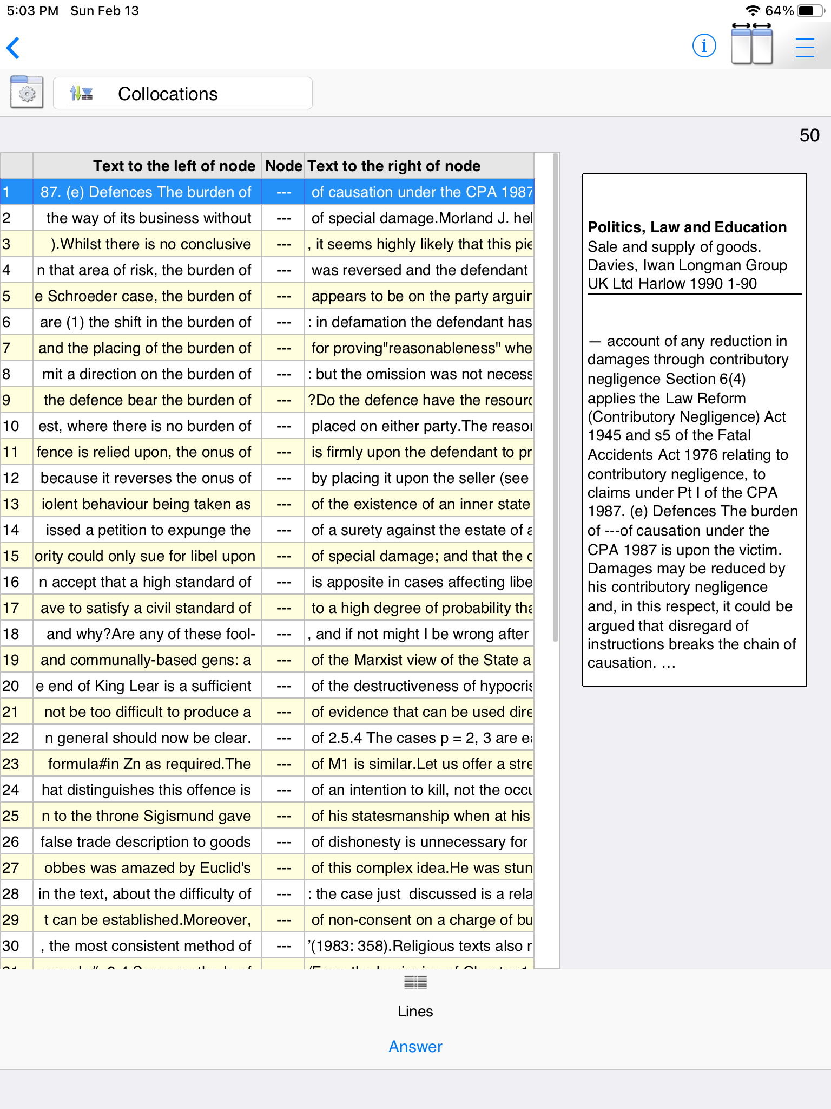
When you are ready to guess, click or tap the Answer button.

Step 2: Using search screen support and formulating your own queries
After you have completed some of the games for learning about academic synonyms, you should find that you have become more familiar with how to read and use concordance data. The next step is to make the most of the different ways to search for your own words and phrases.

There are four different search screens for you to use: Simple Search, Break Down, Compare Two Corpora and Advanced Search (under Research Tools on Full Mode).

When you search with tPM, most of the time you should use specific word forms; don’t generalize to the infinitive form of verbs or the singular form of nouns; the hits retrieved will match the string of letters you have entered.

Simple Search
This is the main search screen and it allows you to enter one or two search queries at a time. If you enter a word or phrase and tap the “hamburger” or 蒸笼menu inside the search box, suggestions will appear.

You can see the number of examples in the currently selected corpus.
You can also see collocations, other word forms and words with a similar meaning.

The suggestions and the number of hits will be different in different corpora. Click here to change to a different corpus.
This button will give you more information about the currently selected corpus.

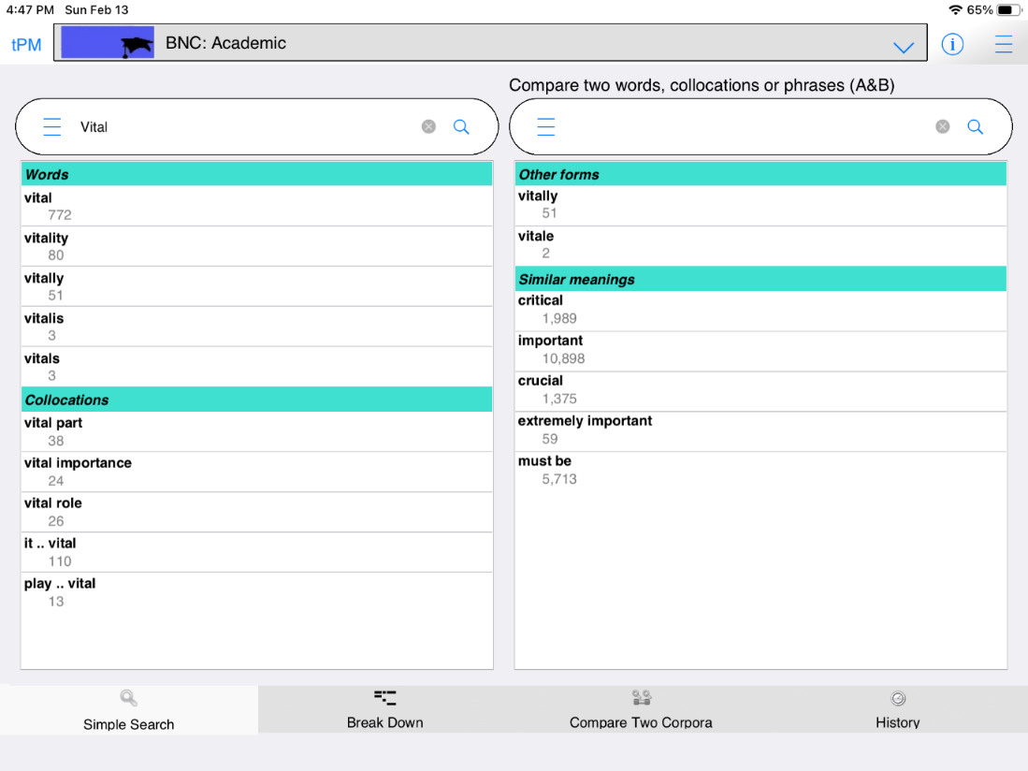
The left-hand side shows single word suggestions and strong collocations. The numbers are the number of hits in this corpus.
The right-hand side will show other word forms and words with similar meanings.

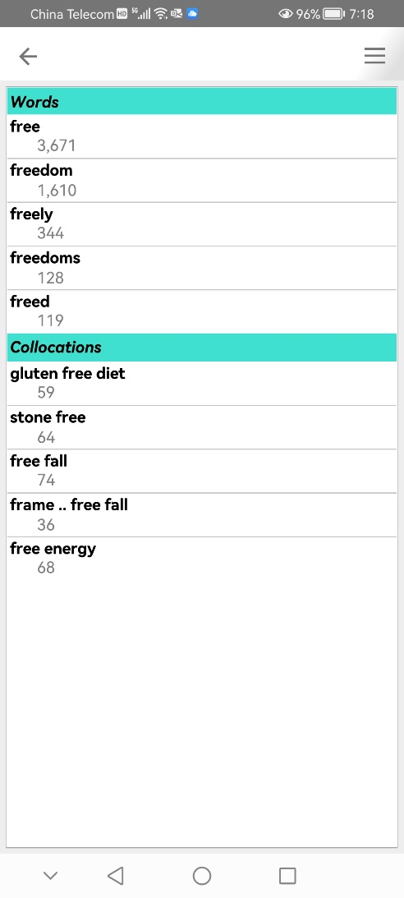
On narrower screens like this Android phone, the suggestions pop up on another screen. Select the item you want and then tap the back button.

Tips:
- When you enter one word, the suggestions will be for longer strings with the same letters (auto-complete) and strong collocations on the left; and other word forms and words with similar meanings on the right.
- The suggestions for similar meanings use several different resources including English-English resources and words which have the same English translation in a Chinese-English dictionary. You can only search for English words, but some suggestions are based on a Chinese-English dictionary.
- If you click or tap the hamburger/蒸笼 button again, you will be given more suggestions.
- When you enter more than one word, the app will try to find a match in the list of strong collocations in this corpus. If no match is found, it does not mean the combination does not exist.
- From the Simple Search screen, you can force the app to show concordance lines and frequency data for combinations of words not stored as a LL collocation in the database, by using three special symbols:
  - Putting _ between words means these words must occur in order with no other words in-between.
  - Putting * between words means these words must occur in order, but there could be zero or more words in-between (up to a total phrase length of 5 words).
  - Putting | between words means these words can occur in any order but all must occur within a 5 word window.
- More advanced searches can be performed using the Advanced Search tab.
On the Break Down tab, we can click the hamburger or 蒸笼 button inside the search box and it will split the sentence into words, allowing us to look at combinations of up to five words starting at the currently selected item.

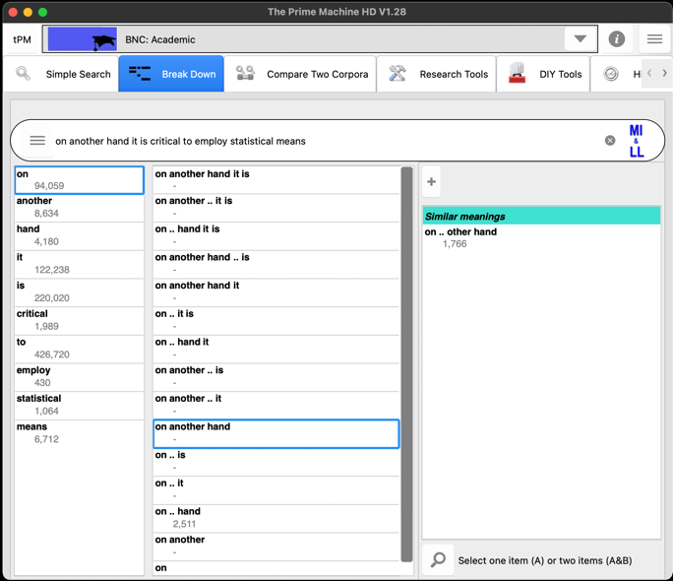
The second column shows combinations of words to the right of the selected word.
If the combination is stored as a LL collocation it shows the number of hits.
You could check concordance lines if you couldn’t guess “On the other hand” is better.
If you click the + button, suggestions may appear.
The first column shows the frequencies of each word in the sentence.

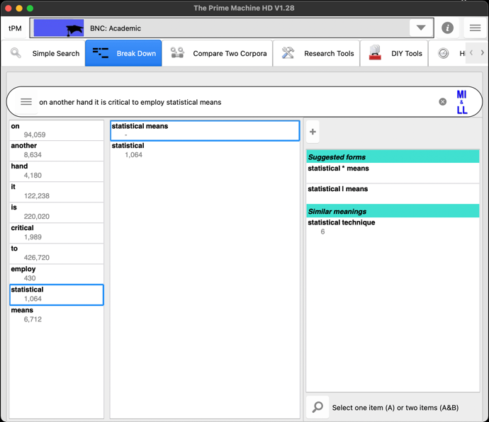
Perhaps statistical techniques would be better?
These two words don’t appear adjacent in this corpus, but they are nearby.
Choosing another word will show combinations with words to its right

On the Compare two Corpora tab, you can enter one word or a phrase and then retrieve concordance lines and other corpus data from two different corpora in one operation.

Results from the main corpus will be displayed on the left (A).

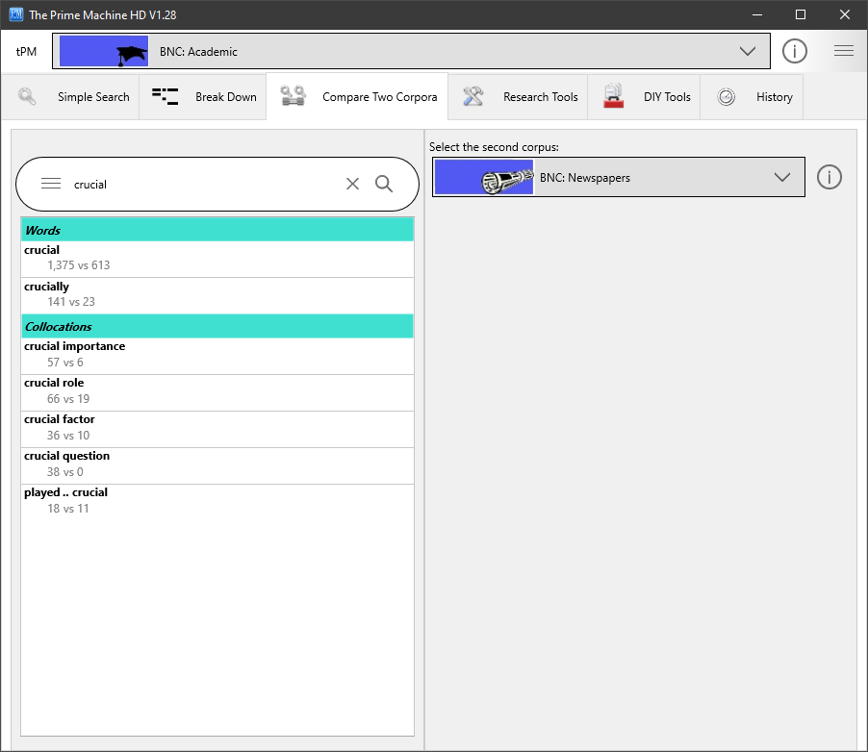
The suggestions will show the frequencies in both corpora, with collocation suggestions based on the strong patterns in the main corpus.
These buttons allow you to change the second corpus or view information about it.
Results from the second corpus will be displayed on the right (B).

On the Advanced Search tab (under Research Tools), you can perform a number of more advanced queries:
- Combining the results of more than one word form by entering multiple words separated by space, using wildcard pattern matching, or selecting the option to include word families;
- Forming patterns for phrases with multiple words in up to 5 slots, with options for the ordering of items and whether or not other words can occur in-between.
- Using filters to get results from one text category or advanced filters based on labels or features such as part-of-speech and position in text.

On the Advanced Search tab as well as getting concordance lines and displaying them on the left (A) or right (B) you can also get frequency tables and plots.

Results will come from the main corpus; click or tap here to change.
Some corpora are split into categories, so you can limit the search to specific groups of texts.

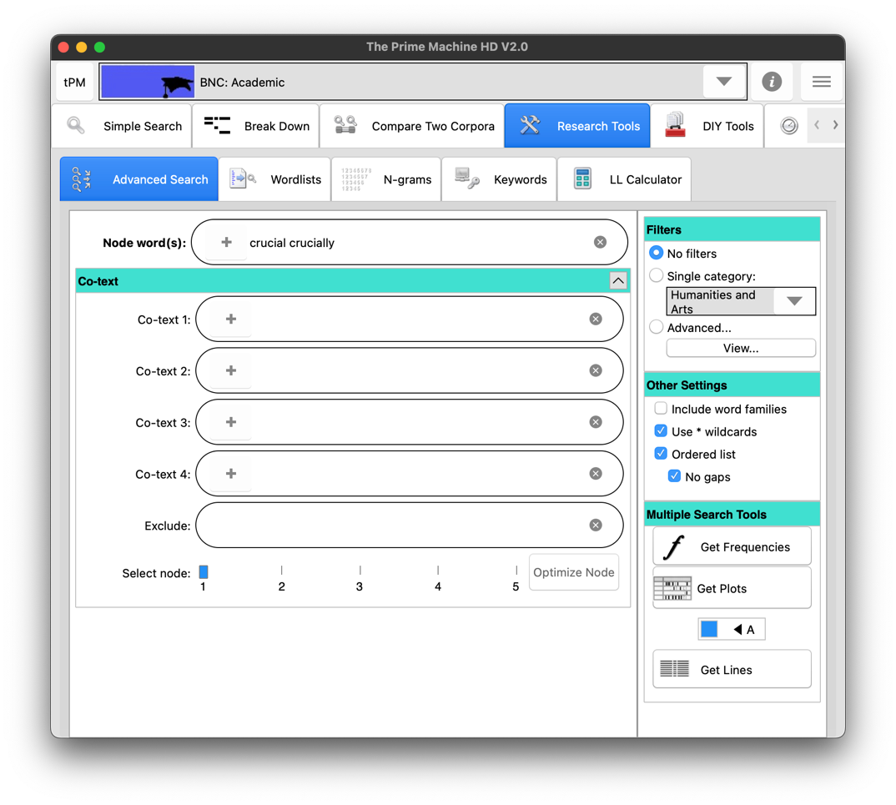
If you enter one word and click or tap on the + button, other word forms for this word in the current corpus will be added to the box.
Enter lists of words separated by spaces to find any of these words and merge all the results.
Clicking or tapping on the A/B button will send the results to the left (A) or right (B) so you can compare two sets of results side by side.

The other settings panel allows you to specify:
- Whether to include all the different word forms in the corpus for each word you have entered. For example, if you tick this option and enter the word analysis the results will include analyses, analyse, analysing, analysed, etc.
- Whether you want to use * to represent zero or more letters. For example, analy* would include all words beginning with the letters analy.
- Whether the words entered in the co-text boxes need to occur in order or in any order and whether or not other words can occur in-between.

The advanced filters menu has two ways of adding additional requirements for the results. The Priming Filters contains the full list of features which are displayed on the Graphs Tab of the results in Full Mode. You can specify a wide range of requirements as follows:
- Whether or not the hit occurs as a title or heading or not;
- Whether the hit occurs in a sentence or paragraph at the beginning, middle or end of the text;
- Whether the hit occurs in a sentence at the beginning, middle or end of a paragraph;
- Whether the hit occurs in the beginning, middle or end of its sentence;
- Whether the hit occurs in Theme (before the main verb) or in Rheme (the main verb onwards);
- Whether or not the hit occurs inside quotation marks, or before, after or between them;
- Whether the hit occurs in a simple sentence or a sentence with subordination (a projecting or other complex sentence);
- Whether or not the hit occurs after modal verbs;
- Whether or not the sentence containing the hit has passive voice, to have or to be as the main verb.
- Whether or not the sentence has “not” in it;
- Whether the hit is a noun, verb, adjective, adverb or other part-of-speech;
- Whether the definite article, indefinite article or possessives occur to its left;
- Whether any prepositions occur nearby;
- Whether words with a strong positive or negative meaning occur nearby;
- Whether the hit has another hit (or another word form) within one sentence before or after it.

Click or tap on a group of settings to reveal a list of possible options.
Click or tap on Select all if you need to reset all these priming filters.

In this example, all the other options for part-of-speech have been unticked, meaning the results will only show those where our node word is a noun.

Note: In Full Mode you can filter the concordance lines you have already downloaded according to these same criteria. If you filter before you search, you will get up to 200 hits matching the specific filters. If you filter after you have retrieved the results, the app will just look inside the results you have already downloaded.

Label filters can be based on the Category or metadata about the text, section, producer (author or speaker), or semantic tags (word meanings).

To find possible label filters, enter the first few letters and click the hamburger / 蒸笼 button.
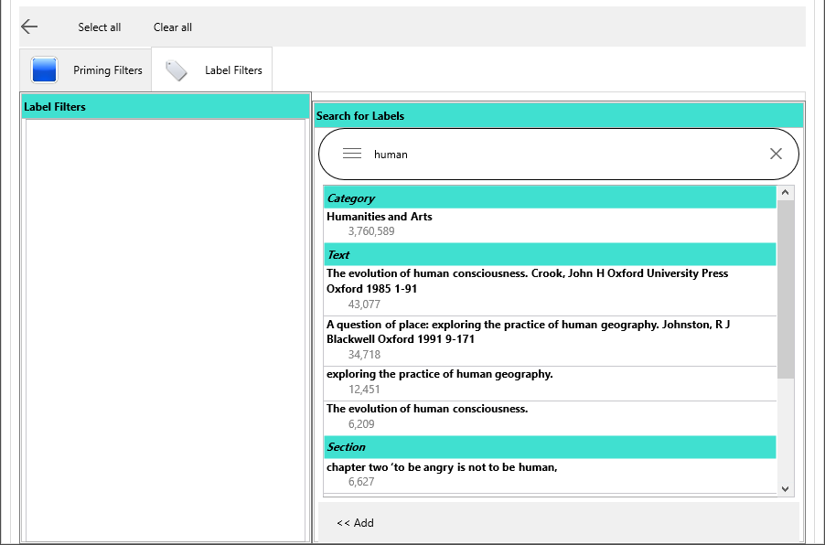
Use the Add button to add the selected label to the list of filters.

If you enter words in the co-text boxes, it is possible that the Node(s) slot contains a very high frequency item such as this or the. It is much more efficient for the server to use a lower frequency word as the node because it will find all the hits of the node first and then filter out results which do not match the pattern. The Optimize Node button will light up and you can click it to adjust which search box is used as the node. Or you can ignore it and just click Get Lines, Frequencies or Plots a second time… but this could mean a delay in getting the results.

Step 3: Analysing the differences between two different words

For this example, Simple Search will be used to compare two words with a similar meaning: significant and important. These words are quite closely related in meaning, so when you enter either one in the first search box and click the hamburger / 蒸笼 button, the other one appears on the right as a suggestion. Select important to put it in the second box.

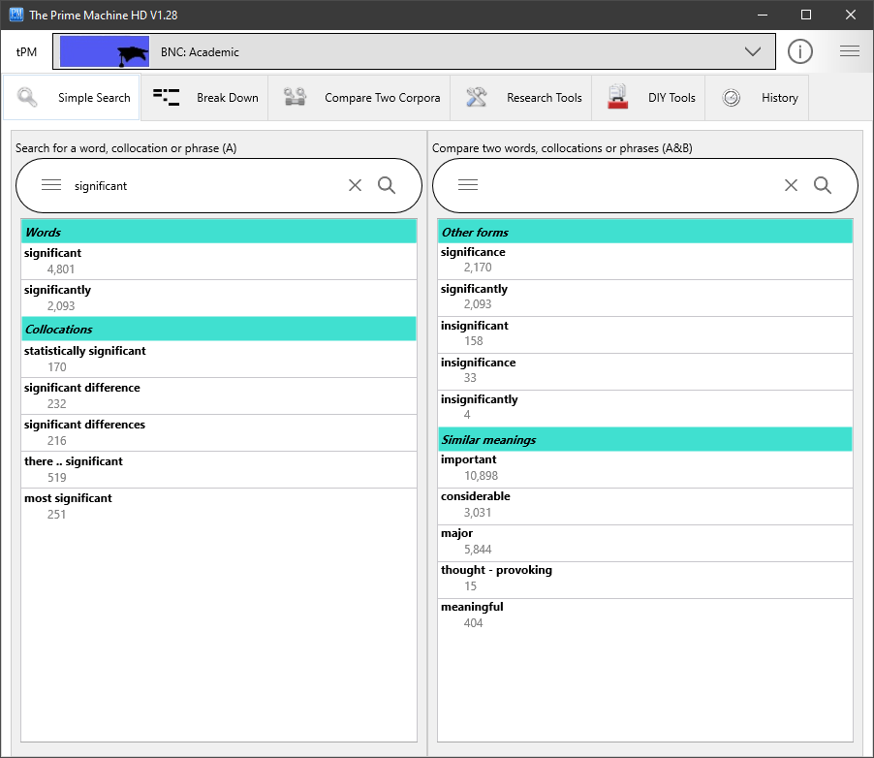

If you already know the two words you want to compare, you can just type them into the boxes and click or tap the magnifying glass in the second search box. Another shortcut is to enter two words separated by VS (in capital letters); when you press enter the two words will be compared.

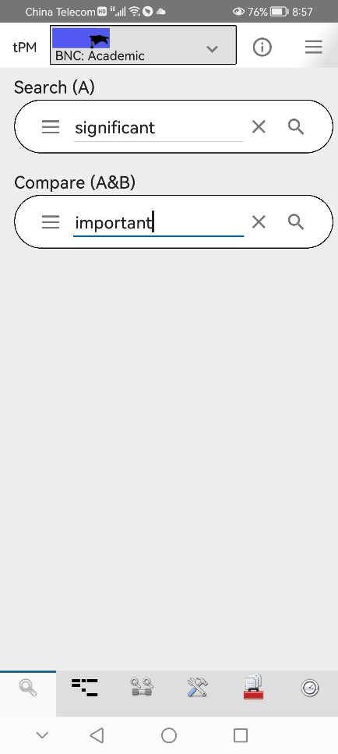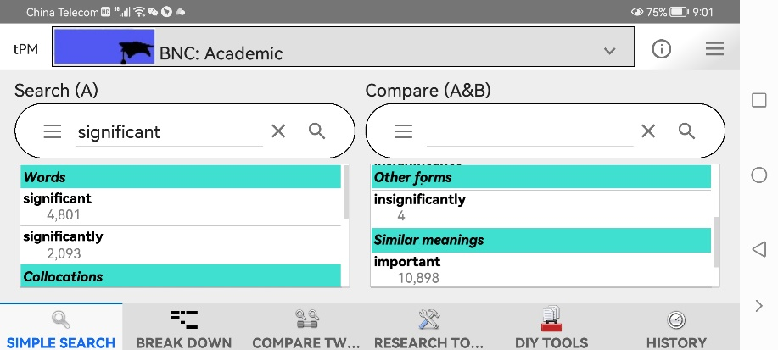
Rotating the device will show the boxes side by side with suggestions underneath.
On a narrow screen like this Android phone, the two search boxes appear vertically; suggestions appear in a pop-up screen.

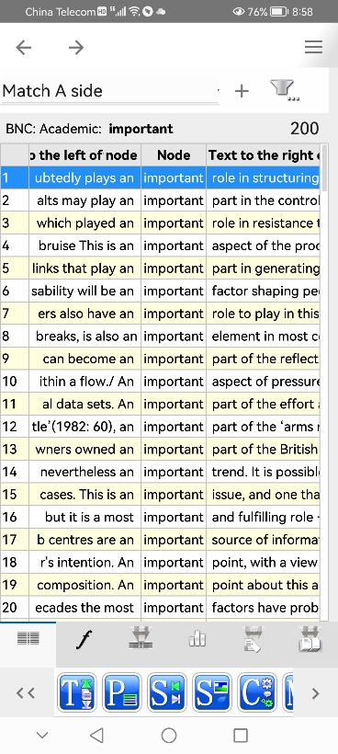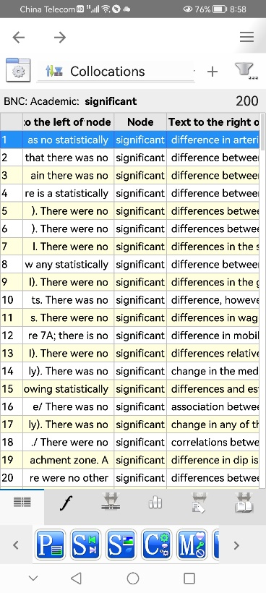
You can view two sets of results like this using Simple Mode or Full Mode. The display for Simple Mode has fewer tabs of results and no blue icons at the bottom.
On a narrower display, results can’t be seen side-by-side, but you can flip between the two sets of results using the forward and back buttons.
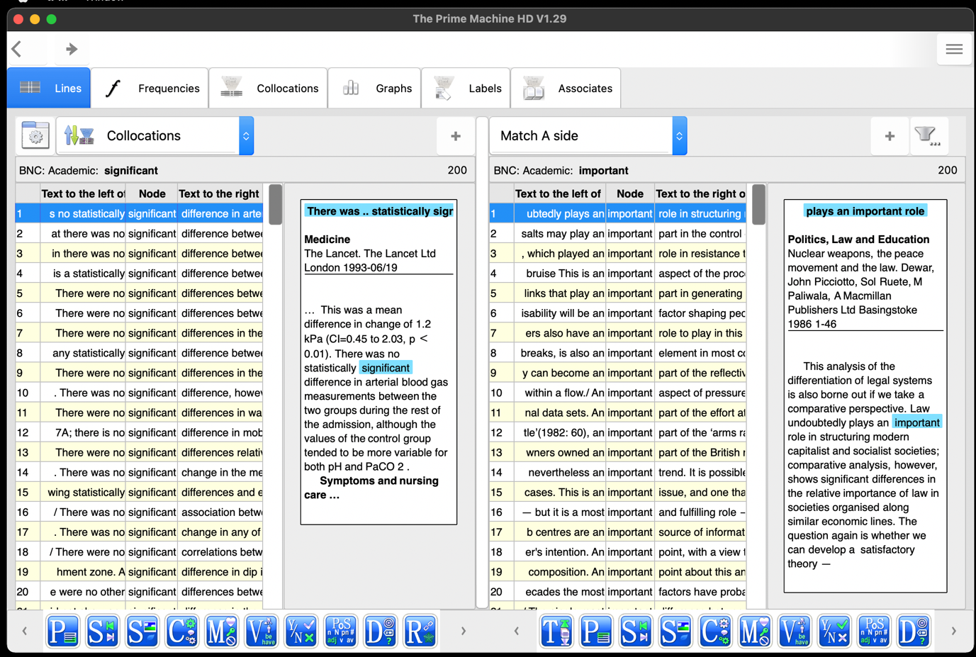

On a wider display, the two sets of results can be viewed side-by-side. As noted on pages 4-6, the display settings can allow you to change between Lines + (above), Lines and Cards (below).

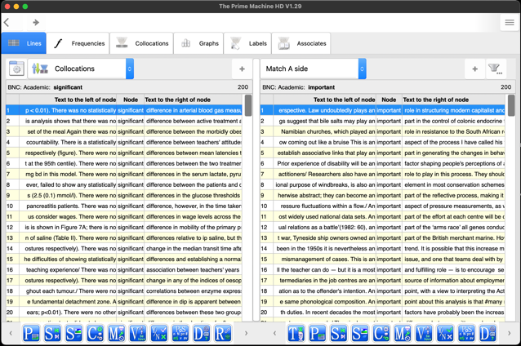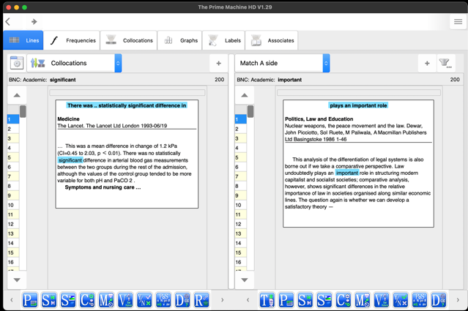

There are many things you can do when you look at concordance lines.

The default sorting method in tPM is using Collocations. This means the lines with the strongest collocations will appear at the top.

Concordance lines and cards can be copied, saved or shared. Double-click, right click or long tap on the lines or the cards to open the menu.

Concordance lines are very useful when comparing the patterns of use of synonyms. When you get used to looking at the Lines displays, you should find you can notice patterns in the use of words to the left and the right of the node. The Cards are useful if you find it hard to understand the context or the likely meaning of a concordance line – it gives you up to one sentence before and one sentence after the sentence containing the node.

For significant and important we can see:

Patterns to the left |  | Patterns to the right
Past tense was and were, often used with There was/were…  Often used with no, with the indefinite article a in several examples visible near the bottom of the screen.  It occurs with statistically. | significant | Occurs immediately before these nouns:  - difference  - differences  - change  - association  - correlations
Present tense plays, play as well as have and has. Fewer cases seem to be in past tense.  Occurs as subject as well as with This is an …  Occurs with indefinite article an but also with premodifier most. | important | Occurs immediately before these nouns:  - role  - part  - aspect  - factor  - element  - point  - issue  - source  - difference

In the top 24 lines sorted using Collocations, only difference occurs in both, but it has a stronger collocation with significant.

Patterns to explore to the left |  | Patterns to explore to the right
Whether the adjective is used in noun phrases or as a predicate.  In noun phrases whether nouns pre-modified by the adjective are usually used with the definite article, indefinite article, negatives, etc.  When a predicate, the kinds of noun (e.g. people, things, problems, processes) being described; and the kinds of linking verb (seemed or was), etc.  Are words of degree used with the adjective (e.g. quite or very)?  Whether other adjectives or adverbs occur.  Tenses (past or present) and modality. | Adjectives | When used in a noun phrase, other adjectives and nouns immediately following the adjective.
In noun phrases whether the noun is pre-modified by certain kinds of adjectives or other nouns; is it usually used with the definite article, indefinite article, negatives, etc.  If used as an object, what kinds of verb are used? | Nouns | If used as subject, what kinds of verb are used?
What kinds of subjects are used (people, things, problems, processes, etc.)?  Are modal verbs used (can, could, may, etc.)?  Is it used as the main verb? | Verbs | If there are objects, what kinds of objects?  Is it a verb often used with or without that?  Are any prepositions used? Do different prepositions have different meanings?  Are there any adverbs?
If it follows a verb, what kinds of verbs and which tenses are common?  Are modal verbs used?  Are words of degree used with the adverb (e.g. quite or very)? | Adverbs | Is the adverb used with an adjective or verb?
You may also be able to notice differences between the kinds of texts in which these two words occur, the section (abstract, introduction, method, results, conclusion), the position in text, paragraph and sentence, and the overall sense of whether it is used with words that have a positive or negative meaning.

Remember to scroll down and look at more than just the top screenful of results. Hopefully, the Collocation ranking method will be useful, but you can also try sorting the results in other ways to reveal other patterns or to work through a fixed random sample.
The Frequencies and Collocations tabs were briefly introduced on pages 7-9. These should give you helpful summaries for all the hits in the corpus (not just the sample of lines that have been downloaded).

The list of differences to look for in the patterns of use for different kinds of words is rather overwhelming. However, reading several examples from the concordance lines should help you not only become aware of differences, but remember them too! The app does the work of fetching and arranging the examples, but you need to use your brain to really find useful differences and to reflect on how these can help you in your own writing. The mental exercise of making discoveries for yourself should help ensure you have a deeper engagement with the examples and lead to better retention than if you were merely given a list of patterns to memorize.

However, in Full Mode, tPM can also help prompt you to look for certain patterns, based on statistical processes which are completed on all the hits of the words in the corpus. The blue icons at the bottom of the screen, and the Graphs Tab can show you some of the strong patterns of usage.

It would take a long explanation to introduce the meaning of all these icons. Some of the letters seen prominently in the icons give a clue as to their meaning – Text, Paragraph, and Sentence for tendencies to occur in different positions, M stands for Modals and D for Determiners. The green elements in each icon indicate the patterns which are statistically significant for the word or collocation used in your query.

But an easier way to use these icons is to click or tap on them, particularly if you can spot differences between the two words you are comparing. In the images above, we can see that the green of the block of text for P is towards the end of the block for significant, but towards the beginning for important. Clicking or tapping on the P icon will show a graph of the proportion of hits in the first sentence, last sentence and middle of paragraphs. The key symbol on the M icon is green in both cases – showing can, could, may and might are associated with the patterns for both words in the entire corpus. The Y/N icon shows the tendency of significant to be used with not. And if the screen is wider or we scroll to the right, we could see both words have a tendency to be used with indefinite articles.

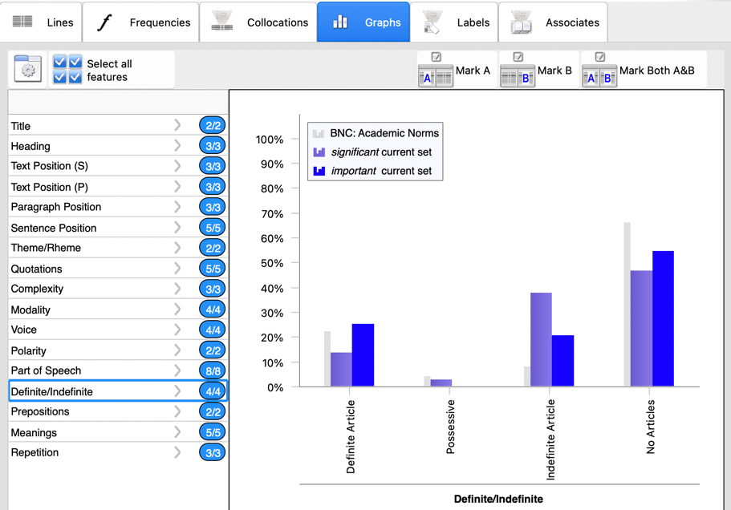
The graphs show data for the current set which means the lines already downloaded. This random sample may have weaker tendencies than the entire corpus; the icons light up according to results for all hits in the corpus.
The graphs tab can also be used to filter the results. This might be useful if one of your search terms can be a noun or a verb, for example. It can also allow you to filter down the long list of results to focus on a particular pattern, such as use with possessives or occurrences in the Rheme of the sentence.

Clicking or tapping on one group of features on the left of the graphs tab (or using the blue button on a narrower screen), takes you to the same kind of menu seen on page 18. If you wanted to only see hits which have been automatically tagged as a noun, for example, you would click or tap on Part of Speech and then untick the other options. Once you have removed the ticks from the features you do not want to include, click Mark A to select matching instances on the left set of results (A), Mark B for the right set or Mark Both. Check boxes will appear with ticks marking lines which match your requirements. You can then use the filter menu (the top-right funnel icon on the Lines tab) to filter out the unselected hits.

The other two tabs on Full Mode can also give you clues about the contexts in which the word often occurs. The Labels tab shows information about the Texts, Sections, Producers (authors or speakers), and the Neighbourhood – the meanings of words occurring nearby the word. This tab can show a lot of information and clicking on one element will zoom up the cloud so you can see more labels for Text, Section, Producer or Neighbourhood.

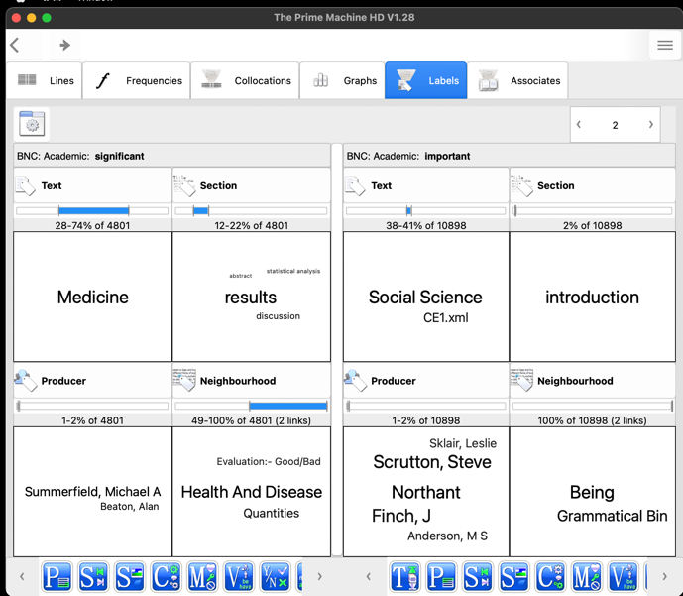

These panels may give you clues as to whether one synonym is more or less associated with a particular text type - something you can also glean from the frequencies tab. It may also show particular sections of the text, especially if it is an academic corpus. The Producer panel is probably less important for analysing academic synonyms. The Neighbourhood panel, on the other hand, may show some of the topics (semantic tags) associated with each word.

The Associates tab on Full Mode provides an overview of some other words which occur frequently in texts where the search terms are also repeated. The text for each hit in the entire corpus is checked to see whether the word or collocation you have searched for occurs as a key word, and then the other key words in those texts are tallied up to give clues about some of the important topics or language used in these texts.

The panels below, show the word significant is prominent in Medicine texts where clinical trials are being reported (patients). In Social Science texts, important may be prominent in texts about social problems, housing and work, while in Politics, Law and Education, it may be associated with words related to teaching and curriculum. Of course, these are only possible interpretations… it would be better to use these results as a starting point for analysing the concordance lines we can see on the Lines tab.

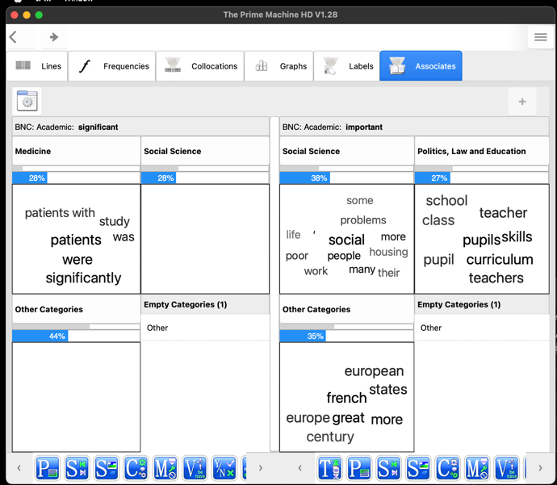
Clicking or tapping the panel headings will zoom them up.
Clicking or tapping the + button once will retrieve more associates if available.

We often find that collocations have different patterns of use from the patterns of the individual words they contain… it could be very useful to take some of the strong collocations for our two synonyms and look these collocations up in tPM. For example, we can compare significant difference with important difference or significant with significant difference. If the combination of words is stored in the database as a LL collocation, frequency charts, extended collocations, graphs, labels and associates will be available.

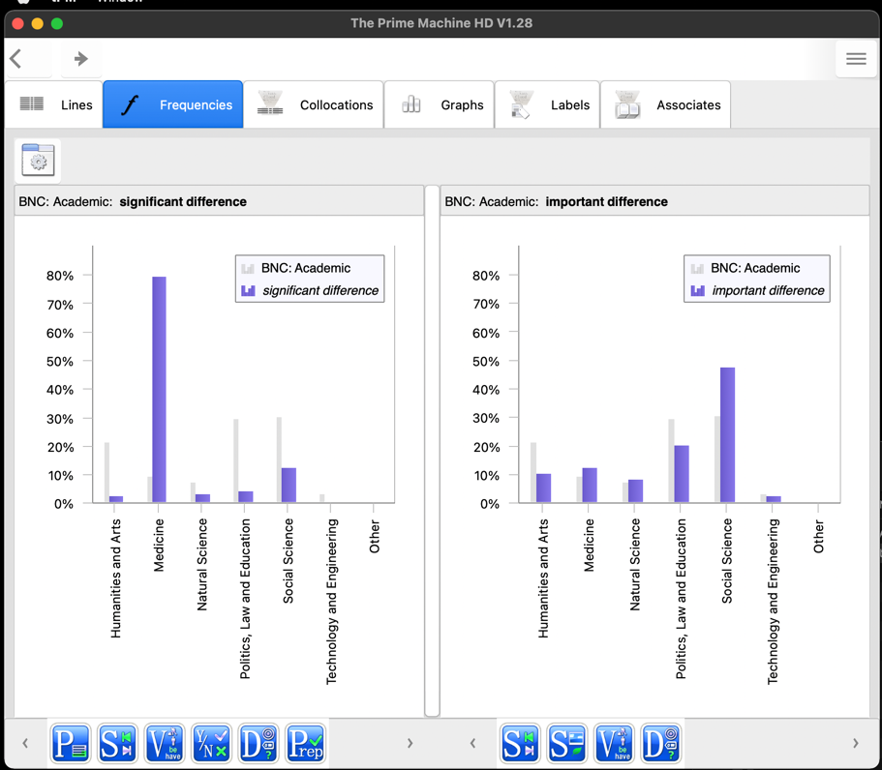

Finally, we often find that words and collocations have different patterns of use in different kinds of texts. If you are wanting to explore academic synonyms and also compare them with their uses in other kinds of texts (newspapers, speech, fiction, etc.), you can use the Compare two corpora option, or start by exploring words using a more general corpus like the whole of the British National Corpus.

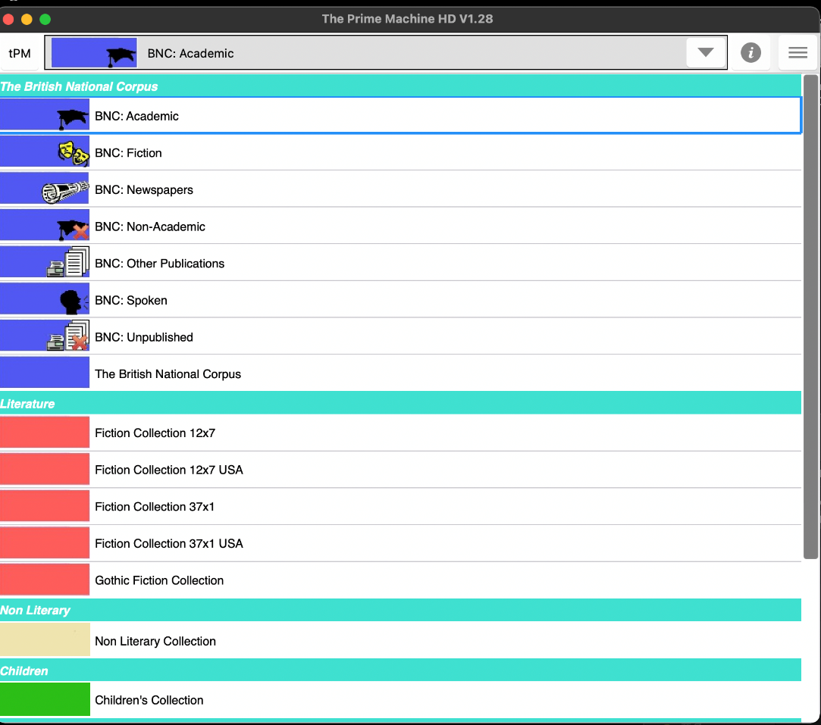

tPM is a powerful tool for comparing synonyms. Even by following just a few of these clues, you should be able to use your detective and reasoning skills to learn more about the contexts in which writers prefer one word over another, and the co-texts that are formed through collocation and grammatical patterns.

For some of the background to these methods and approaches, please see the tPM Help Selected Bibliography available from https://www.theprimemachine.net/help.html.

Dr. Stephen Jeaco - 杰大海
www.theprimemachine.net

This work is licensed under the Creative Commons Attribution 4.0 International License. To view a copy of this license, visit http://creativecommons.org/licenses/by/4.0/ or send a letter to Creative Commons, PO Box 1866, Mountain View, CA 94042, USA. If you use this document, please include a link to the tPM Help Selected Bibliography available from https://www.theprimemachine.net/help.html.

First published: Thursday, 17 March 2022

Last updated: Saturday, 09 September 2023

